January1st to December 31st, 2016
Annual Report
Social Health Protection Project
{Gilgit Baltistan}

AKDN Consortium

Table of Contents
- Project Overview 2
- Progress and achievements 5
- Success Stories 11
- Key Challenges and Constraints 15
- Lessons learned and Recommendations 16
- Planned activities for next quarter 17

Section
1

Project Overview

- Project at a glance:
(A brief summary of the project, its objectives, geographical coverage, expected outcome etc.)

Health shocks are the most severe shocks when analyzing the determinants of poverty in any population. In Gilgit Baltistan, physical access to secondary health services is one of the biggest problems mainly due to high cost of rarely available transport. However, The Government of Gilgit Baltistan is committed to improving the access to the quality healthcare services, and is therefore launching a Social Health Protection approach through a Health Insurance (HI) scheme with financial support from German Government through KfW. HI will cover requirements for hospitalization including child birth; common diseases of childhood; injuries and accidents; common surgeries and medical ailments requiring hospitalization.
Goal: The overall goal of the Government of GB’s programme is to improve the health status of the population, especially the ultra-poor, and to reduce poverty through reduction of out of pocket health expenditures.
Objectives of the Micro Health Insurance under SHP Initiative
The objectives of the health insurance under Social Health Protection Initiative are:
- To design and introduce an insurance product attractive to the majority of the general population of the region with particular emphasis on the 21% of the poorest population group in the Gilgit district through a reduction of catastrophic and out of pocket health expenditures.
- To improve in health status of the population of the district Gilgit through improved quality of care and access to secondary health care services.
- To improve health seeking behaviour amongst the target population through awareness raising and community mobilization
- To promote the product among general population targeting enrolment of 29% of population by end of 5 years.
Two segments of population in Gilgit District will be insured for Health insurance under Social Health Protection Initiative:
- The poorest population group in the project area (21% as per BISP data)whose premium will be paid by Department of Health GB out of the programme funds
- The population who will buy the insurance voluntarily by paying insurance premium themselves.
Geographical coverage
The project is implemented in 11 Union Councils (UCs) including Municipal Areas of Gilgit town of Gilgit District with an estimated population of 216,087. AKRSP team acquired the data of the poorest 21% households from Benazir Income Support Programme (BISP). The team processed the data into a readable form and segregated it by each UC and selected 5496 households out of 8332 households provided by the BISP Office.

Project update:
Brief description of key progress made so far (major milestones only)

- BISP Data for 8000 population was acquired through the support OPM and DOH-GB support in mid-February 2016. Data filtered and finally 5496 households were selected on the basis of lowest 21 percentile for verification.
- Institutional and staffing arrangements were made by AKDN in March.
- Jubilee Life Insurance and AKRSP offices in Gilgit have provided dedicated spaces for supporting the implementation of this Initiative. One room in JLI’’s Office based in Gilgit in ZS Plaza, Opposite Radio Pakistan, Main Shahrah-e-Quaid-e-Azam, Jutial, Gilgit has been fully dedicated as project office for implementation of SHP
- Inception Report was approved was approved by the Department of Health-Gilgit Baltistan in April.
- Verification and enrolment of households begun in mid-March and 4833/5480 families(88%) enrolment has been achieved by December 2016

- Communication Strategy was developed and endorsed by OPM and Department of Health Gilgit Baltistan in July

- Marketing material including brochure , health cards , envelop and banners were designed and were approved by the OPM, KfW and DOH-GB
- Formal launching of Sehat Hifazat Cards held in June by the Chief minster GB and Ambassador Federal German Republic and Country Director KfW for Pakistan health
- Proposal for Organization Development Fund developed and submitted and finally approved by the Department of Health GB and KfW
- Distribution of health cards begun in July and 4365/4833 (90%) health cards were distributed by December
- After initial assessment, negotiation started for empanelment of Private, NGO and public sector hospitals and resultantly MOU was signed with DHQ and City hospitals, Aga khan Medical Centre Gilgit,Sehat Foundation Hospital Danyore
and Family Health Hospital, Gilgit.
- Service delivery begun in mid-August
- Products for wider enrolment designed and tabled for discussion with OPM in November.

Project staff from AKRSP conducted verification of households and their enrolment with the initial process of holding first dialogues in 11 union councils with involvement of Local Support Organizations and Civil Society .The following CSOs remained participated: Wildlife Conservation Organization , Rising Educator, Sakwar Youth Organization ,Elvain Consultant ,Konodass Welfare Organization and Pakiza Welfare Organization . In those dialogues the project team shared with each organization purpose of the project, verification process and methodology of its implementation in detail. Large number of Board members and LSOs staff attended those meetings. The dialogues were followed by one day training session for 28 Community resource persons (CRPs) from 12 different organizations like LSO and CSOs focused on orientation and application of BISP data verification tool.
Drawn on their past experiences of health insurance schemes, various members of LSOs suggested below mentioned ideas to project team to consider for effective implementation of Social Health protection Initiative.
- Exhibiting good behavior by staff at panel hospitals as well as Jubilee’s own staff with the insured clients and community members
- Avoid printing error in the health cards and timely delivery of cards
- Enhancing enrolment /opening period for the insurance scheme.
- Better communication between the project team and LSOs
The LSOs appreciated the idea and showed willingness to work for the Initiative but at the same time they were concerned about using the BISP data.

During the year no significant development changes and development were reported in Gilgit district with regard to health sector. However, PM’s Programme for Social Protection has been initiated in Askardu and Diamir districts which have no direct implication for this Initiative.
Government Initiative of China-Pakistan Economic Corridor would potentially bring positive economic impact in GB, which will have good implication for the health system and people. Currently, there are initial rumours about establishment of a 100 beds hospital in Aliabad under CPEC.
Global Affairs Canada has been supporting AKDN for health projects focused on MNCH in GB, these projects have been investing on health promotion, diseases prevention, staff capacity development, health facility renovation and equipment support for provision of good quality gender and environment sensitive health services including basic and emergency obstetric and neonatal care. 20 government primary health care facilities in Hunza, Nagar, Astor, Ghizer and Gilgit districts and one public private partnership model at Civil hospital have been supported under those grants and also a number of AKHS health facilities. As such those projects wouldn’t have any direct implication for SHP Initiative. However, in the longer run some positive knock- on effect of those project interventions could be anticipated at panel hospitals of this scheme and in entire health system of GB.
.

- Financial summary of Organisational Development Funds:
- Total Committed Amount: Pak Rs. ………….. …
- Total OD expenditure incurred to date: Pak Rs. ………….. …
  - From Programme funds: Pak Rs. ………….. …
  - From HIO’s resources: Pak Rs. ………….. …
- OD expenditure during reporting quarter: Pak Rs. ………….. …
- OD funds allocated for next quarter: Pak Rs. ………….. …

Section
2

Progress and achievements

Give detailed description of the progress against project milestones as following list (but not limited to it, add other milestones if needed)

- Population coverage:
{the coverage of eligible population (numbers and percentage) and also the number of households from general population who were enrolled in the scheme}

Coverage of eligible population 4833/5480 (88%)
Coverage of distribution of health cards 4365/4833 (90%).

Status of Enrolment and Distribution of Health Cards
S.No |  | Name of Union Council | Enrollment Status |  |  |  |  |  | Status of distribution of Health Cards
 |  |  | Targeted Hhs |  |  | Enrolled Hhs |  | un identified Hhs | Distributed to LSOs | Distributed to beneficiaries by LSOs and COs |  |  | Cards to be  distributed
1 |  | Sakwar | 240 |  |  | 231 |  | 9 | 230 | 230 |  |  | 10
2 |  | Chakarkote | 453 |  |  | 422 |  | 31 | 419 | 409 |  |  | 18
3 |  | Damote | 1057 |  |  | 969 |  | 88 | 950 | 932 |  |  | 119
4 |  | GMC | 1171 |  |  | 873 |  | 298 | 854 | 735 |  |  | 105
5 |  | Shykyoute | 628 |  |  | 550 |  | 78 | 515 | 410 |  |  | -
6 |  | Nomal | 180 |  |  | 179 |  | 1 | 179 | 179 |  |  | -
7 |  | Rahimabad | 219 |  |  | 214 |  | 5 | 202 | 202 |  |  | -
8 |  | Bagrote | 267 |  |  | 263 |  | 4 | 261 | 261 |  |  | 4
9 |  | Jalalabad | 540 |  |  | 525 |  | 15 | 519 | 515 |  |  | -
10 |  | Haramosh | 363 |  |  | 363 |  | 0 | 361 | 361 |  |  | 112
11 |  | Danyore | 362 |  |  | 244 |  | 118 | 243 | 131 |  |  | 368
 | Total |  |  | 5480 | 4833 |  | 647 |  | 4,733 |  | 4,365 | 368

- Empanelment of health facilities:
{Describe the process involved in empanelling of health facilities, key features of empanelment criteria (the detailed criteria may be annexed to the report) and number of hospitals (public and private separately) there were empanelled up to date and during the quarterly}

Initially JLI identified 21 health facilities including hospitals and primary health care facilities offering Basic Emergency Obstetric services for prospective empanelment in Gilgit district. Letters were sent to 10 hospitals by-hand and they were given a period of 2 to 3 weeks to reply. Letters to the remaining 11 hospitals were offered but they were declined by those hospitals. The survey was based on a pre-defined criteria form for empanelment of JLI and the existing Jubilee Health Insurance Team of Gilgit was actively involved in conducting the survey in close coordination with the Jubilee Team in Karachi. The survey involved a visit to the hospital by JLI’s official followed by an interview with the hospital personnel and inspection of the hospital with observation of its facilities, structure and staff strength using JLI’s criteria form.

Of the 10 hospitals that accepted the letter, five hospitals allowed the survey to be conducted and extended their co-operation for filling of the criteria form. From the remaining five, one hospital was still under construction, hence did not allow the survey. Another hospital deferred the survey because they were in the process of signing agreements with consultants. The remaining three hospitals that accepted the letter backed out at the time of the survey due to their limited staff, limited, space, lack of doctors availability and reluctance to follow the credit mechanism.

The 11 hospitals that did not accept the letter were military and government hospitals, however, two of these hospitals did allow JLI’s officer to conduct the survey and fill the criteria form.

CMH requires approval from GHQ Rawalpindi for any kind of documentation; hence progress in that direction was quite limited.

Regarding the scoring, Gilgit Medical Center got the highest score and AKHSP set ups in Zulfiqarabad, Danyore and Nomal achieved lowest score since they are units that focus mainly on mother and child health and maternity cases.
Subsequently negotiation was started with the five hospitals about services, prices , quality, availability and facilitation of patients who will be visiting those hospital as insured under the scheme and finally MOUs were signed with the following hospitals.

1 Aga Khan Medical Centre Gilgit
2-Sehat Foundation Hospital Danyore.
3-DHQ Hospital Gilgit.
4-City Hospital Gilgit.
5-Family Health Hospital, Gilgit

Provision of health services has been initiated from the empanelled hospitals.

- Service delivery:
Detail of services availed by insured patients (total admissions, segregation by causes of admission, gender and age group of patients, type of health facilities (public or private) etc.

Total 23 admission were reported since mid Agust, of that 16 went to Public health facilities and 7 were admitted at private hopsitals.

S.No | Causes of Admission | Gender | Age Group | Hospital Name | Total Admissions
1.  2.  3.  4.  5.  6.  7.  8.  9  10  11  12  13  14  15.  16.  17.  18.  19.  20.  21.  22.  23. | COPD  Uterine hypertrophy  Lt- Tibial (Exotosis)  SVD  LSCS  Hemorrhoids, external, uncomplicated  Post pain  Haemorrhoids, external, uncomplicated.  Appendicitis, acute w/o peritonitis  Fracture lower arm,  Calculus, kidney  Fracture lower arm,  Pnemonia  Enteric fever  Blunt trauma  COPD  Hernia, inguinal, unilateral  Upper respiratory infection, acute, NOS  Cellulitis/abscess, unspecific  COPD, NOS  COPD, NOS  Cholelithiasis, NOS  LSC | Female  Female  Male  Female  Female  Female  Female  Male  Female  Male  Female  Male  Male  Male  Male  Male  Male  Male  Female  Female  Female  Female | 57  31  14  28  40  42  42  29  14  10  68  16  3  12  45  50  3  7  37  65  65  35  18 | Private  Private  Private  Public  Public  Public  Public  Public  Public  Public  Private  Public  Public  Public  Public  Public  Private  Private  Private  Public  Public  Public  public | 23

- Claims processing:
Number of claims received, processed, settled and rejected (segregated by public and private hospitals up to-date and during the reporting quarter, amount claimed by hospitals and disbursed to hospitals. (detailed list by each hospital may be annexed). Average time taken by HIO for claims processing.

Type of Hospitals | # Claims Submitted | Amount Claimed | # Claims Settled | Amount Disbursed | Rejected Claims
Public Sector | 16 | 1’41’030 | 16 | 1’41’030 | -
Private | 7 | 1’09’417 | 7 | 1’09’417 | 1

All claims were settled within 2 weeks’ time.

- Complaint management:
{Mechanism of complaint management. Total complaints lodged and addressed, most commonly raised complaints)

Complaint boxes have been placed at SHP Office and Aga Khan Medical Centre Gilgit. UAN number (021-111-111-544) is available on the Sehat Tahaffuz Health Cards, no complaint has been lodged till so far by anyone. Complain numbers are displaced at all hospitals. Around 20 complains, mostly showing concerns about non covering OPD, eye, dental and mental diseases in the service package. Suggsetion also came for including CMH hospital and Aga Khan Health Centre,s at Danyore, Nomal And Zulfiqarabad in the panel list .

- Organisational development:
Details of activities undertaken for organisational development – building up an ‘insurance infrastructure’ including range of interventions for improving quality of services, system strengthening, smooth delivery of services etc,

Dedicated office established was established for the project, staff have been assigned tasks. Site for establishment of facilitation counter identified in coordination with administrators at DHQ hospital and City hospital. Counters were established and trained staff deployed for facilitation at City and DHQ hospitals. A representative of JLI is also placed at AKMC Gilgit for facilitating patients to get hospitalized as the insured of Social Health Protection Initiative.

AKDN team will be advocating at DOH level for instituting a system at public hospitals for retaining portion of hospital income earned through this Initiative to be utilized for improving patient care systems, services and staff capacity to ensure quality care.

- Marketing:
Details of marketing activities and impact of these activities.

Formal launching ceremony of health insurance scheme was arranged at Serena hotel Gilgit on June 3rd. Several types of print material were used for marketing of health insurance including a backdrop, banners were displayed at three sites, six standees were developed and displayed at venue of the event , flyer; complaint box, envelop for the health card were developed , some were displayed and the rest were distribute among the participants . Around 120 people participated from government health department, AKDN, Civil Society organizations, BISP beneficiaries, media and other government line departments. Chief Minister, GB, Health and Population Welfare Secretary , Ambassador of Germany , Country Director KfW and other notable guests participated in the event.

JLI staff also gave detailed presentation entailing product features, enrolment, claim processes and reimbursement at 11 major events held in the territories of Union Councils for distribution of health cards. Similarly brochures were also distributed along with cards for 4000 household heads/representatives who had attended those sessions.
Key messages and communications have been developed .These messages and communications will be spread to masses through:

1. Wall chalking.
2. Digital signage/Kiosks in panel hospitals.
3. Outdoor sites have been near GMC, DHQ and City hospitals.
4. Advertising on local Cable Network.
5. Advertisements on local newspapers.
6. Ground level activities to promote the insurance and this scheme.

Success Stories
Include any success stories with photos (if any)
Section
3

Government of Gilgit Baltistan Launched Sehat Hifazat Programme in Gilgit, Baltistan

Social Health Protection Initiative was launched officially in Gilgit Baltistan on June 3rd, 2016 in graceful ceremony participated by Chief Minister of Gilgit Baltistan, German Ambassador to Pakistan HE. Ms. Ina Lapel, First Secretary in German Embassy Almot Knop, KFW Country Director Mr. Wolfgang, Project Director KFW Dr. Masuma Zaidi, Secretary Health and Population Affairs, Raja Rasheed Aly, government officers, Mr. Sohail Fakhar General Manager/Group head of JLI, Dr Sharif AKF and other AKDN officials, Representatives of community based organisations and enrolled beneficiaries.
The German Government through KfW Development Bank is supporting Government of Gilgit Baltistan for this EUR 1 million (PKR 115) Scheme which is awarded by the Department of Health GB through a competitive bidding process to AKDN consortium comprising of Aga Khan Foundation Pakistan, Jubilee Life Insurance, Aga Khan Rural Support Programme and Aga Khan Health Service, Pakistan. 21% of poorest households get health insurance in district Gilgit under this scheme, however, an additional 29% population of Gilgit district will be covered through other similar products over the five years project period, the premium for such products will be paid by individuals.
The overall goal of the Government of GB’s programme is to improve the health status of the population, especially the ultra-poor, and to reduce poverty through reduction of out of pocket health

The event started with an effective video clip prepared by KFW, welcome by AKDN and JLI presentation on salient features of the Sehat Hifazat insurance under social health protection. In his welcome speech, Sohail Fakhar Jubilee Group Head of Life Insurance, thanked government of Gilgit Baltistan and KfW for carrying out a transparent bidding process for implementation of Social Health Protection- Health Insurance Initiative- which will be called Sehet Hifazat. He highlighted the importance of the health insurance scheme in the context of Gilgit-Baltistan for protecting the poor from catastrophic and out of pocket health expenditures where geographical and financial challenges are enormous. He expected that Sehet Hifazat will be implemented in Gilgit district with full support of Department of Health and lessons learnt from this Initiative will inform designing future projects in much better and improved form and may be replicated in other districts with the support of government of Gilgit-Baltistan
expenditures.
Salient Feature of the Programme: Under this scheme population will be insured for hospitalisation through payment of a nominal annual premium of Rs. 1700 per family of seven members i.e. Rs. 243 per person per year.
The premium of the poorest 21% households of Gilgit District will be paid by Government of Gilgit-Baltistan out of the programme funds. The list of the poorest households will be provided by Government. This product will also be offered to general population by Jubilee Life.
The health insurance under this scheme will cover all ages starting at birth and include maternity care, internal medicine, general surgery, gynae and obstetrics, ophthalmology and ENT etc. The insured population can acquire healthcare from empanelled hospitals both in the public and private sector. The benefits will be up to a maximum of Rs. 25,000 per person per annum
There will be no exclusions of pre-existing conditions (with the exception of some specific “standard exclusions” such as injuries due to suicide attempts, drug addiction or overdose, cosmetic surgery, etc).
Pre and post hospitalization up to one day prior to hospitalization and up to five days from the date of discharge from the hospital shall be part of the package rates.
This scheme provides cashless facilities at empanelled hospitals. For identification purposes, each insured household will be issued a Sehat Hifazat Card.

Secretary Health delivered a keynote speech describing background of SHP, engagement of GB government with KfW on it, bidding process, award of contract, objectives of SHP. He appreciated German government for financial support and OPM for technical support that enabled DOH and AKDN to launch the SHP today.

In his remarks Mr. Wolfgang termed the event as an achievement of an important milestone in SHP initiative. He also gave important figures on impact catastrophic health expenditure on poverty. He shared that health insurance under social health protection is key strategy in not only in improving access of poor to quality-assured health services but also in reducing poverty. He assured DOH that OPM will be there to support technically, if needed, DOH can also contact KFW.

In her brief remarks German Ambassador shared that German government has fruitful partnership with government of Pakistan and also with Govt of GB and SHP is result of that partnership. She highlighted importance of health insurance and a way of cohesive societal support through risk pooling. She emphasized importance of taking responsibility by government to protect poor. 11 million euros were committed in existing phase by German government for SHP and a new commitment of 8 euros agreed for extending as SHP is “close to our heart”. Government’s increasing co-financing will be important for sustainability of SHP. She shared that in KP 50% of the population will be covered by government from its own resources.
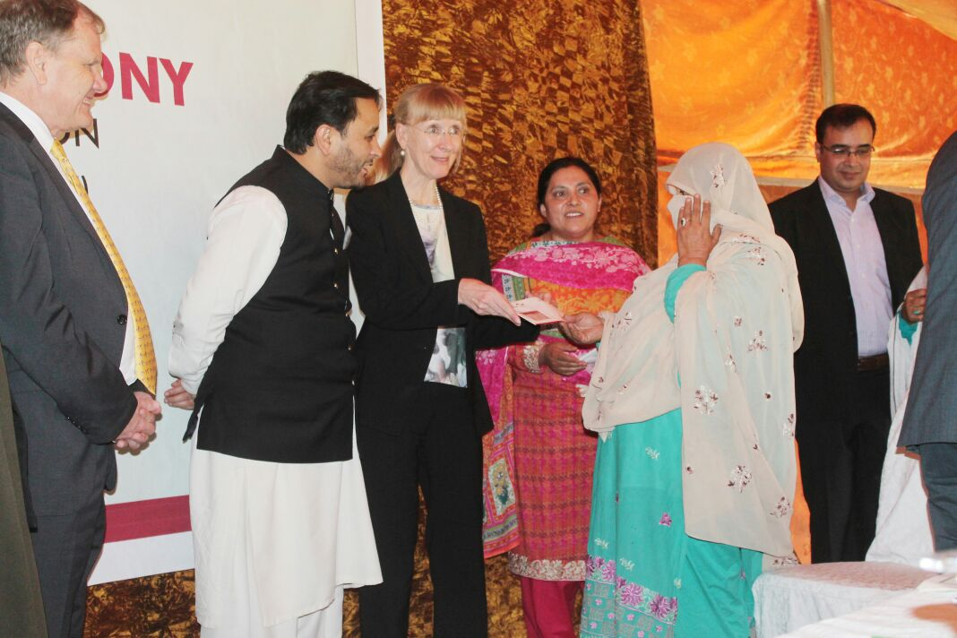
Chief Minister Gilgit Baltistan M thanked German government for its support. He said that through a transparent bidding process SHP contract was awarded to AKDN. He expressed his confidence on AKDN and shared that if this pilot project will succeed then Govt of GB will increase its share in budget 4 times. He said that this project 40000 people will be covered in Gilgit district. He requested German government to continue and enhance it financial support.
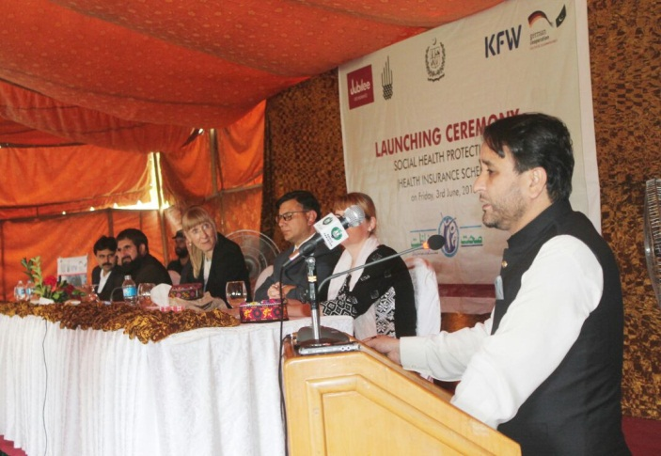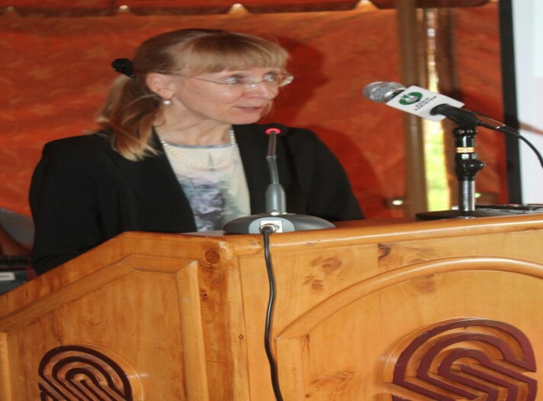
Sehat Hifazat cards were distributed by CM and Ambassador to six beneficiary-household heads (3 male and 3 female HH heads).

Provision of health services under this scheme was begun in mid-August2016 through four empaneled hospitals in both public and private sector, which are available in Gilgit town.

Organizing 11 major events at all Union Councils across Gilgit with the support of LSOs and CBOs and engagement and participation of government officials and political figures particularly CM GB in one of the events for distribution of health cards was a great success. A strong message was communicated to the participants that Social Health Protection Initiative is in fat a government programme, AKDN role is just to ensure its implementation based on past experience of implementing similar ventures in GB .

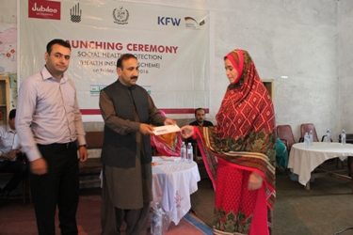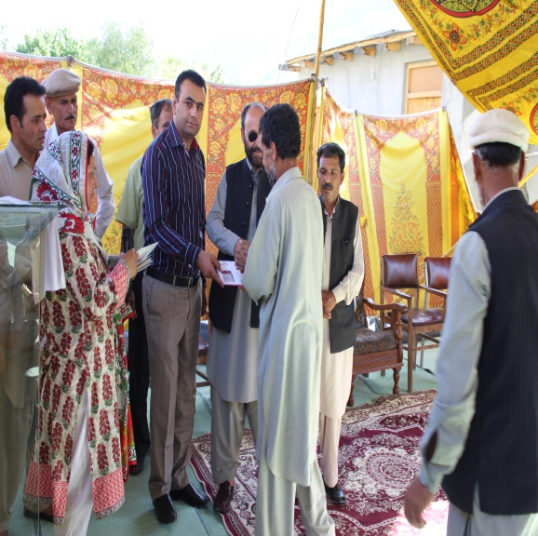

Key Challenges and Constraints
Section
4

Highlight important challenges and problems faced during the reporting quarter and remedial actions taken.

- Initial delay in acquisition of BISP data was overcome with the support of OPM
- Data filtering by UCs consumed considerable amount of time, similarly verification of beneficiaries remained a cumbersome and mammoth exercise which could have been potentially avoided.
- The process for distribution of health cards was interrupted and halted for few weeks due to time taken for redesigning, approval of artwork, reprinting and dispatching of some IEC material on lines suggested by the higher officials of DOH GB
- Negotiating contracts with private and public hospitals for empanelment was very challenging due to scarcity of hospitals in Gilgit district.
- Long-time taken for opening bank account for the project due to changed procedures by the government for NGOs and subsequently delay in release of funds.
- Seasonal migration BISP beneficiaries to the high altitude pastures affected timely enrolment
- Un-identified Households from the BISP List, as result data was further filtered for 4 union councils equivalent to missing numbers to match the total numbers, LSOs and COs will continue tracing those households
- Error in BISP data such as double entry of households was another challenge

Due to above challenges, some of the planned activities couldn’t be completed as per the timelines envisaged in the inception report, notably, verification, enrolment and distribution of health cards much longer times than originally envisaged. The same have ben communicated to OPM and DOH Official in various meetings.

Similarly, AKDN Consortium was unable to meet originally planned dates for development, presentation, and implementation of products for wider enrolment after necessary approvals from OPM and DOH-GB. However, timely technical assistance by OPM was helpful for effective in implementation of key milestones.

Lessons learned and Recommendations
Section
5
Lessons learnt and recommendations

- Verification of BISP beneficiaries is not easy task particularly in GBs context and require more time, similarly, distribution of cards requires much longer time so the timelines envisaged in the inception report were not realistic for both purposes

- Development of products and costing of those products for wider enrolment was not an easy process and required substantial homework and proper understanding of local socioeconomic situation and health seeking behaviours.

- Training of all stakeholders especially of those who are in direct contact with communities and beneficiaries is essential for the program success especially in communication and behaviour change and social ethics.

- The scheme provided an opportunity for LSOs and CSOs to increase their outreach and credibility within their jurisdiction. During orientation sessions and subsequently during cards distribution it was observed noticed that most of the target beneficiaries had no membership in VOs/WOs, Implementation of this initiative is bridging the gaps among the LSOs and very poor segment of the population and this will hopefully increase the participation of poor in these organizations with its useful ramification both for the LSOs and the SPHI beneficiaries.
- People have high expectations from health service providers at empanelled hospitals.
- Marketing and clear communication about the benefits of the product to the beneficiaries is important for utilization of services.
- Implementers have to be proactive for including time and space in their work plans to accommodate political pressures and influences in order to achieve their targets.

Based on the above lessons learnt during the first year of implementation, It is highly recommended that OPM should continue staying flexible about timelines for implementation of various project milestones and activities and also inform DOH-GB and KfW about this recommendation.

OPM’s support will be required for approval of proposed products by DOH-GB for wider enrolment.

Planned activities for next quarter
Highlight the activities planned for next 90 days
Section
6

- Increasing population coverage
 | Activity description | Location/District | Tentative completion date
- Verification of missing households |  | Gilgit town | 31st January
- Distribution of remaining health cards |  | Gilgit | 28 February
- Presentation of products for wider population to OPM and DOHGB  - Agreement on preferred option for Implementation of the product |  | OPM Islamabad | January by 30th January  Mid- March

- Organisational development
Training title and description | - Location/District | - Tentative completion date
Establishment of patient facilitation counter and deployment of staff at empanelled hospital | - Gilgit | - Mid January
Training and capacity building of empanelled hospitals staff on product features, customer care, claim processing and reimbursement | - Gilgit | - 30 January

- Marketing
Marketing activity | Location/District | Tentative completion date
- Development and production of print and broadcast materials |  | 1st week of February
- Training of LSOs and Community Resource Persons in marketing of products for wider enrolment |  | -February
- Development and installation of bill and directional boards having key messages imprinted on it |  | 31 January
- Other Project-related Activities

Activity description | Location/District | Tentative completion date
- Enrolment of wider population | Gilgit | July 31th 2017

