Social Health Protection Health Insurance Programme

Consulting Services for Programme Implementation, Pakistan
(Ref No: BMZ 2009 66 168)
Progress Report (January to June 2019)
Date of submission:
September 2019

About Oxford Policy Management
Oxford Policy Management is committed to helping low- and middle-income countries achieve growth and reduce poverty and disadvantage through public policy reform.
We seek to bring about lasting positive change using analytical and practical policy expertise. Through our global network of offices, we work in partnership with national decision makers to research, design, implement, and evaluate impactful public policy.
We work in all areas of social and economic policy and governance, including health, finance, education, climate change, and public sector management. We draw on our local and international sector experts to provide the very best evidence-based support.

Executive summary
-
-
-
-

Table of Contents
Executive summary ii
List of abbreviations vii
2 Structure and contents of the report 8
3 Key Indicators in KP & GB compared to National: 9
Key health status indicators (national, KP and GB)* 9
4 Latest developments in the health sector 10
4.1 Khyber Pakhtunkhwa (KP) 10
4.2 Social Health Protection 11
4.3 Post 2018 Plans for Phase I of KfW Supported SHPI in Khyber Pakhtunkhwa 11
4.4 Federal Health Insurance scheme 11
4.5 Post 2018 Plans for Phase I of KfW Supported SHPI in Gilgit Baltistan 12
5 Scheme progress in Khyber Pakhtunkhwa 14
5.1 Key Accomplishments during the reporting period 14
5.2 Program Enrolment 15
5.3 Service Provider Network 16
5.4 Wider Enrolment 20
5.4.1 Wider Enrolment During Last Three Quarters 21
5.5 Service Delivery 22
5.5.1 Beneficiary admissions 22
5.5.2 2019 Monthly Admissions 28
5.5.3 Age & Gender Wise Distribution of Admissions 30
5.5.4 Treatments Provided 31
5.5.5 Public Service Providers Utilization 32
5.6 Claims 33
5.7 Complaint Management 33
5.8 Gate Keeping 34
1.1. Steps to Improve Gate Keeping 35
5.8.1 IT tools for assisting claim processing 36
6 Organisational Development 38
Part 2: Gilgit-Baltistan 39
7 The overall approach of the Social Health Protection Initiative in Gilgit Baltistan 40
Aga Khan Development Network (AKDN) Consortium, comprising Aga Khan Foundation Pakistan, Aga Khan Rural Support Programme and Jubilee Life, is implementing the scheme of MHI in Gilgit District under a contract with DOH-GB for five years since August 2016. 40
7.1 Programme Area and Population 40
Figure 5: Map of Gilgit District with its Union Councils 41
8 Key Highlights of the Reporting Period 42
8.1.1 Expanding coverage of insurance in Gilgit District under SHPI: 42
8.2 SHPI Related Initiatives by government of GB 43
8.2.1 Chief Minister Health Endowment Fund Gilgit Baltistan 43
8.2.2 Initiation of Exit Interviews of Beneficiaries 43
9 Project Update 44
9.1 Population Coverage 44
9.1.1 Population Eligible for enrolment in government/KfW funded SHPI 44
9.1.2 Enrolment amongst Wider Population 44
Table 4: Status of Enrolment of Households (June 30, 2019) 45
9.2 Coordination and Review Meetings 45
9.3 Social Mobilisation and Marketing Activities 45
9.3.1 Social Mobilisation 45
Figure 6: Glimpses of a Community Mobilisation Session 46
9.3.2 Marketing Activities 46
9.3.3 Stakeholders meetings 46
9.4 Service Delivery 47
Table 8: Top 10 Diagnosis of admitted cases (Eligible and Wider enrolment) Jan-Jun 2019 47
9.4.1 Quarterly Admissions 48
Figure 8: Quarterly trend of Admissions (Jul 2018 to Jun 2019) 48
Figure 9: Average number of quarterly visits by 100 insured persons 48
9.4.2 Admissions in Hospitals 49
Table 9: Admissions in each Hospital (Jan-Jun 2019) 49
9.4.3 Age and Gender Distribution by eligible and wider enrolled 50
Table 10: Distribution of admissions by Age group, gender and type of enrolment 50
9.4.4 Length of Stay 50
Table 11: Average length of stay by each hospital (Jan-Jun 2019) 50
10 Claims Settlement 52
Table 12: Claims settlement pertaining to patients from eligible HHs 52
Table 13: Claims settlement pertaining to patients from wider enrolment 52
11 Complaint Management 53
12 Financial summary of OD funds utilisation: 54
For Jan – June 2019 54
13 Financial Report Jan. – June 2019, SHPI Gilgit & Khyber Pakhtunkhwa 55
14 Planned OPM activities for next two quarters 60
15 Key Issues and Recommendations 63
Annex A Brief Report on Analysis of Exit Interviews at Empanelled Hospitals by PMU for SHPI Gilgit 65
Table 1: Source of Information on Utilisation of Insurance Card 66
Figure 1: Knowledge of Correct Limit of insurance coverage 66
Figure 2: Behavior of Health Facilitation Officer 67
Figure 3: Paid any amount during treatment 68
Figure 4: Alternate sources to meet treatment expenditure if there was no insurance 69
Table 2: Views on including other benefits in insurance package 69
Table 3: Reason for choosing the hospital for treatment 70

List of abbreviations
AKDN Aga Khan Development Network
BISP Benazir Income Support Programme
BMZ Bundesministerium für wirtschaftliche Zusammenarbeit und Entwicklung
COPD Chronic Obstructive Pulmonary Disease
CSO Civil Society Organisation
DHQ District Headquarters
DMO District Medical Officer
DOH Department of Health
GB Gilgit Baltistan
HFO Health Facilitation Officer
HIO Health Insurance Organisation
JLI Jubilee Life Insurance Company
KfW Kreditanstalt für Wiederaufbau
KP Khyber Pakhtunkhwa
KPO Key Punch Operator
LHW Lady Health Worker
LSO Local Support Organisation
NBP National Bank of Pakistan
NGO Non-Governmental Organisation
OD Organisational Development
OPM Oxford Policy Management
PC-1 Planning Commission Proforma 1
PKR Pakistani Rupee
SCB Standard Chartered Bank
SECP Securities and Exchange Commission of Pakistan
SHP Social Health Protection
SLIC State Life Insurance Corporation of Pakistan

Structure and contents of the report
The report provides aa account of the progress made and activities carried out during the first half of 2019 in the implementation of the Social Health Protection programme supported by KfW. It has been prepared in line with Annex 7 of the 'Separate Agreement' between Kreditanstalt für Wiederaufbau (KfW), the Departments of Health in Khyber Pakhtunkhwa (KP) and Gilgit Baltistan (GB). However, some of the provisions and guidelines of the Annex 7 are difficult to meet at this stage as some of the monitoring indicators specified in Annex 7 will only become available as a result of surveys and focus group discussions at various stages of the implementation of the scheme.
The structure of the report has been modified in light of the comments from KfW on the last Six Month Report.
This report first summarises the latest developments in the health sector in both KP and GB. Following this there are two sections – one each for KP and GB. Each section is based on information submitted by HIO, observations and analysis of data by the OPM team. The final section summarises key challenges, recommendations and next steps.

Key Indicators in KP & GB compared to National:

Key health status indicators (national, KP and GB)*
Indicator | Pakistan | KP | GB
Under-five mortality rate (per 1,000 live births) | 74 | 70 | 89
Infant mortality rate (per 1,000 live births) | 62 | 58 | 71
Neonatal mortality rate (per 1,000 live births) | 42 | 41 | 39
Total fertility rate | 3.6 | 4 | 4.8
Contraceptive prevalence rate (any method) | 35.4 | 28.1 | 33.6
Contraceptive prevalence rate (any modern method) | 25 | 23 | 30
Percentage of women delivering at health facilities (institutional delivery) | 66 | 62 | 62
Percentage of births attended by skilled birth attendants | 69 | 67 | 64
Fully immunised children (12–23 months) | 66 | 55 | 57
*Source: Pakistan Health and Demographic Survey 2017–18.

Latest developments in the health sector

Khyber Pakhtunkhwa (KP)
Government in Khyber Pakhtunkhwa has placed Social Health Protection at the centre of its manifesto and its policies with a commitment to continue and expand SHPI across Pakistan.
The government in KP has developed a Health Policy with the following Vision, Mission, Outcomes for the Health Policy 2018 – 2025:
Vision: Optimal health across the lifespan for the people and communities of Khyber Pakhtunkhwa.
Mission: To develop and implement a sustainable, coordinated, integrated and comprehensive health system at all levels, based on the Primary Health Care approach through the District Health System, to ensure universal access to quality health care.
Principles: Health policy implementation in Khyber Pakhtunkhwa will be driven by the following key principles:
- The Health Department will ensure universal health coverage for the people of Khyber Pakhtunkhwa based on:
  - Universal and equitable coverage
  - Accountable, transparent, sound management & governance
    - Results based management
    - Community oversight and involvement
  - Quality of care
  - Safe for patients and staff
  - Innovative and responsive service delivery
Universal Health Coverage is to be achieved as part of overall government commitment to achieving Sustainable Development Goals (SDGs) and “Health in All Policies”.
Outcomes: The Department of Health Khyber Pakhtunkhwa will realise its vision and achieve its Mission by bringing about a set of Outcomes in partnership with stakeholders and partners.
The Policy Outcomes have been chosen which align with the Outputs Based Budget for three years 2018 – 2021, namely:
1. Enhanced coverage and access to essential health services, especially for the poor and vulnerable
2. Measurable reduction in the burden of disease, especially among vulnerable segments of the population
3. Improved human resource management
4. Improved governance, regulation and accountability
5. Enhanced health financing for efficient service delivery and financial risk protection for people of KP.
As a major strategy, the government of KP has committed to continue with the SHPI in the province and also target 80% population of the province to be covered by at least some form of health insurance thus promoting voluntary purchase of health insurance.

Social Health Protection
Procurement process for the next phase of the government funded health insurance scheme called the Sehat Sahulat Program has completed and the contract with State Life Insurance Corporation for providing health insurance to the beneficiaries funded by government of KP is close to signing. The PMU has initiated procurement process. For the period starting January 2019 onwards, the government of KP has made a major change in the health insurance, mas it is now committed to pay the premium for 100% population of the province. Another change is that coverage is now provided to a ‘family’ and not a ‘household’ as in the previous scheme. The Tertiary care procedures limit has been enhanced to Rs 400,000 from Rs 350,000. In addition, prostheses and joint replacements will also be covered.
While for Punjab, Baluchistan, Gilgit Baltistan, Azad Kashmir, Islamabad Capital Territory and former FATA the federal PMU is managing the procurement process, in Khyber Pakhtunkhwa the provincial government has the authority to have a separate procurement process, benefits package and management arrangements.

Post 2018 Plans for Phase I of KfW Supported SHPI in Khyber Pakhtunkhwa
The contract between GoKP and SLIC was for three years which ended in December 2018. Upon completion of the contract, the GoKP has carried out a procurement process for acquiring services of a health insurance company for 2019 onwards. While the contract has not been signed, State Life Insurance Corporation has been selected and negotiations are on going between the government and SLIC. OPM is supporting KfW and the government of Pakhtunkhwa to work out plan for continuing the partnership beyond 2019 for which an Options Paper has been developed and shared separately.
  - Federal Health Insurance scheme
The Federal Government of Pakistan launched a Prime Minister’s Health Insurance scheme under its 'National Health Programme' (NHP) in 2015, under which, poor families will be provided health insurance for hospitalisation in secondary and tertiary health facilities. The programme was envisaged to be implemented all over Pakistan, starting with 23 districts in all four provinces, the Federally Administered Tribal Area, Azad Jammu and Kashmir and GB. The programme is being implemented in districts across Pakistan and will extend to other provinces on the endorsement of the provincial government.
The change of government has resulted in review of the policy overall. The federal government has now decided to provide 100% funds for Islamabad Capital Territory, Gilgit Baltistan, Azad Kashmir and former FATA districts (now called the Newly Merged Districts of Khyber Pakhtunkhwa). Punjab and Baluchistan provincial governments will provide funds for the scheme from provincial budgets, however, procurement process will be managed by federal PMU for the programme. The design of the card and the name of the scheme has also been changed to highlight the Tehreek-e-Insaf. It will now be called “Sehat Ka Insaf” programme while the design of the card to be issued to the beneficiaries will have the Pakistan Tehreek-e-Insaf flag.
  - Post 2018 Plans for Phase I of KfW Supported SHPI in Gilgit Baltistan
The present government in Gilgit Baltistan has two more years before elections are held. The political situation has changed for Gilgit Baltistan as, unlike before, the political party in power at the federal level is different than the one in GB.
The federal government is planning to extend the insurance scheme under the PMNHP, to include more districts for another three years. The plan includes expanding the scheme to all districts of GB to cover population with PMT score of 32.5 or less according to the BISP poverty survey carried out in 2009.
Social protection being a priority area in Development Cooperation between German and Pakistan governments, KfW has shown interest in extending the Social Health Protection scheme to other districts in Gilgit Baltistan. The government of GB is interested in continuing its cooperation with KfW and benefits from technical and financial assistance provided by KfW. A number of meetings have been held to discuss continued cooperation and financial and technical assistance by KfW in this important initiative. Although the federal government has planned extension of PMNHP to all districts of GB with firm financial commitments, the government of Gilgit Baltistan appreciates the technical and financial support provided by KfW in this important area, and prefers continuing with the health insurance scheme in Gilgit with KfW funds.
During a series of meetings held between the department of health GB, the Federal Ministry of Health Regulations and Coordination and then subsequently with a high ranking KfW Mission, it has been agreed that:
- KfW will support SHPI implementation in Gilgit district and move part of the funds from Phase II of the KfW support to be used for extension of the IPD services starting 2019.
The beneficiary population will be all households that fall below PMT score of 32.5. It is estimated that approximately 21,000 households under the cut-off PMT score in Gilgit district will be covered with health insurance. Under phase-I of this initiative, population below 16.17 PMT score is already enrolled for provision of cashless secondary health care services. Tertiary Care Services will also be provided to the already enrolled population below 16.17 PMT.
- The ‘voluntary’ scheme will be implemented in the districts supported by KfW.
- Since the agreement with Jubilee Life Insurance Company for providing health insurance services to around 5,000 households is valid till 2020, this arrangement will continue.
- Main features of the scheme in Gilgit proposed for 2019 onwards are:
  - Secondary care hospitalisation benefits would be provided upto Rs 25,000 per member of the beneficiary household
- Priority Tertiary care hospitalisation benefits would be provided upto Rs. 300,000/- per household per year.
- Pre and post hospitalization treatment including medicine and other necessary prescriptions up to 1 day prior to hospitalization and up to 5 days from the date of discharge from the hospital shall be part of the package rates.
- Transportation:
- Rs. 10,000/- per tertiary discharge in addition to limits
- Rs. 2000/- per secondary discharge.
The annual premium for full benefit package is estimated to be around Rs.3500 per Household, However the exact premium will be determined after completion of bidding process and selection of insurance firm which may vary from the estimated premium.

Scheme progress in Khyber Pakhtunkhwa

Key Accomplishments during the reporting period
- Under Govt funded scheme portability of services has been introduced and the beneficiaries can now avail services from the network of more than 250 empanelled hospitals across Pakistan in case of emergency.
- Wider enrollment has been successfully implemented in Mardan & Malakand and group insurance policies have been issued. The services are being provided to the enrolled beneficiaries in the empanelled hospitals.
- Portability under wider enrolment has been introduced for getting health care services from any empanelled hospital throughout the province.
- A dashboard has been developed for presentation of the activities under Wider Enrolment.
- Activities have been initiated for development of better product under wider enrollment. The design phase has been completed and after the costing is done it would be submitted to Security & Exchange Commission for getting the approval to market the product.
- A portal has been developed and implemented for genuine addition/deletion of members to the family tree from the empanelled hospitals of their residence district instead of physically visiting the Peshawar office for addition deletion of members.
- Issuance of duplicate card has been made possible from the district of residence through empanelled hospitals instead of visiting Peshawar Office.
- Complaint handling has been made more effective by posting an additional complaint officer. State Life and its Social Health activities have been brought under PMDU (Prime Minister Delivery Unit) where the citizens can lodge complaints directly to the Prime Minister of Pakistan. These complaints are handled by the complaint officer along with handling other complaints received from PMU & Toll-Free number
- The Institute of Radiotherapy and Nuclear Medicine (IRNUM) hospital, working under the Pakistan Atomic Energy Commission was empanelled last year for management and treatment of cancer patients which has provided services to more than 3000 patients. Contract has been signed with Atomic Energy Commission for starting services for treatment of cancer from its 16 hospitals across the country. For Khyber Pakhtunkhwa, SLIC is in contact with Swat Institute of Nuclear Medicine And Radiotherapy (SINOR) (Swat), Institute of Nuclear Medicine And Radiotherapy (INOR) Abbottabad), D.I.Khan Institute of Nuclear Medicine And Radiotherapy, Dera Ismail Khan (DINOR) and Bannu Institute of Nuclear Medicine And Radiotherapy (BINOR) for providing the services to our beneficiaries in Khyber Pakhtunkhwa, so that they don’t have to spend time and resources on traveling to Peshawar in order to get cancer treatment from IRNUM (Peshawar).

Program Enrolment
Enrolment in the KfW supported Social Health Protection Initiative in the four districts of Khyber Pakhtunkhwa currently stands at 784,718 individuals or 95,405 households (averaging around 8.2 members in a household). The enrolment drive in the four districts was primarily undertaken in first half of 2016 while the remaining was undertaken in first half of 2017.
Table: Number of beneficiaries enrolled
District | Households enrolled | Individuals enrolled | Households (Census 1998) | % Enrolled | Households (Census 2017) | % Enrolled
Chitral | 8,645 | 78,011 | 45,228 | 19.1% | 61,619 | 14.0%
Kohat | 19,760 | 157,325 | 113,461 | 17.4% | 121,344 | 16.3%
Malakand | 18,000 | 146,158 | 82,495 | 21.8% | 91,414 | 19.7%
Mardan | 49,000 | 403,224 | 230,502 | 21.3% | 311,868 | 15.7%
Total | 95,405 | 784,718 | 471,686 | 20.2% | 586,245 | 16.3%
While premium for the beneficiary households are paid on annual basis, the cards distributed to the beneficiaries are valid for five years of the program period.
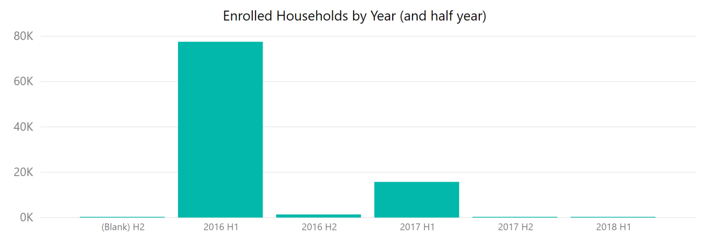
Out of the total individuals enrolled, largest enrolled individuals belonged to the age bracket of 16 and 64 years (68.3% of total enrolled individuals).
Number of children under 15 years of age enrolled is significantly lower. According to the Census, population of the province under 5 is 16.25 % while population under 15 years is 47.20%. Scrutiny of record, interviews with key informants including District Medical Officers, HFOs, staff of NGO responsible for enrolment and members of beneficiary households was carried out to determine reasons for the low enrolments of children. One explanation given was that large proportion of families do not have formal registration documents (Form B) for their children under 18 years of age. Such documentation was necessary to certify that the children are members of the household. Another reason was that beneficiary households preferred to enrol grown-up people as they expected older members of the family to have need form hospitalisation.
For new-borns the data in the list of individual beneficiaries gets added by SLIC only when delivery has taken place through hospitalisation services availed through SHPI, or a new-born is admitted in the hospital by the enrolled household.
Table 3: Age of enrolled individuals
District | Age brackets of individuals enrolled (as on July 2019) |  |  |  |  |  | Grand Total
 | 0-5 | 6-15 | 16-64 | 65-74 | >75 | No data
Chitral | 87 | 18,931 | 53,377 | 3,079 | 2,260 | 277 | 78,011
Kohat | 138 | 42,866 | 107,868 | 3,824 | 2,287 | 342 | 157,325
Malakand | 290 | 42,778 | 97,654 | 3,010 | 2,095 | 331 | 146,158
Mardan | 762 | 108,894 | 277,065 | 9,676 | 5,915 | 912 | 403,224
Grand Total | 1,277 | 213,469 | 535,964 | 19,589 | 12,557 | 1,862 | 784,718
% of total | 0.2% | 27.2% | 68.3% | 2.5% | 1.6% | 0.2%

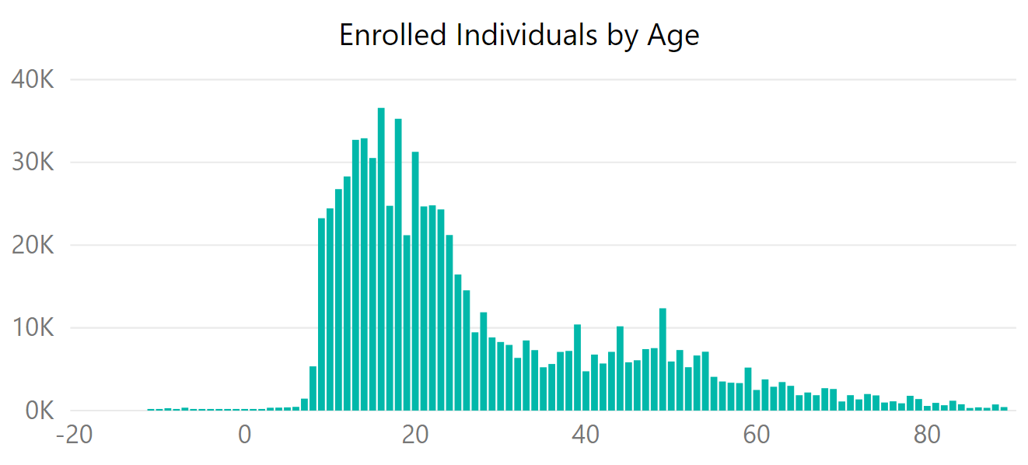

Service Provider Network
The service provider network for SHPI includes hospitals that have been empanelled for providing cashless inpatient hospitalisation to enrolled members of beneficiary households. The PMU and State Life Insurance Corporation periodically review performance of service providers, removing underperforming hospitals and adding hospitals. Currently 18 hospitals are empanelled in the four districts.
Most of the empanelled hospitals are located in the district headquarters which are usually the bigger towns in the districts. While efforts have been made to identify hospitals with adequate facilities and staff for empanelment, there are no such hospitals in Kohat, Malakand districts.
Additionally, there are 80 hospitals throughout the province empanelled for the KP Government SHP Phase II from which services can also be availed by the Phase I beneficiaries.
As SLIC is contracted by the federal government and the government of Punjab for providing health insurance, it has empanelled hospitals across Pakistan, which have been authorised to treat patients of the four districts in case of emergency or if the patients have moved to other parts of the country and cannot travel to the district of their residence and/or Khyber Pakhtunkhwa Province.
SHPI Phase-I contract between Department of Health and SLIC assigned the role of approving empanelment criteria and list of empanelled hospitals to the government and the actual process of empanelment and negotiations to the Insurance Company.
List of empanelled hospitals in the four districts is given hereunder.
 | Hospital | District | Type
1 | Aga Khan Medical Centre Booni | Chitral | Private
2 | Rural Health Centre, Shagram | Chitral | Public Private Partnership
3 | Rural Health Centre, Mastuj | Chitral | Public Private Partnership
4 | THQ Garamchashma | Chitral | Public Private Partnership
5 | DHQ Chitral | Chitral | Public
6 | Health Ways Hospital | Kohat | Private
7 | Frontier Hospital | Kohat | Private
8 | KDA Hospital | Kohat | Public
9 | Liaqat memorial Hospital | Kohat | Public
10 | Sajida Islam Hospital | Mardan | Private
11 | Mardan Medical Complex | Mardan | Public
12 | Junaid Medical Centre | Mardan | Private
13 | District Headquarter Hospital | Mardan | Public
14 | Al Sayyed Hospital | Mardan | Private
15 | Shiekh Yaseen Hospital | Mardan | Private
16 | Gul Medical Centre | Malakand | Private
17 | Siraj Shaheed Hospital | Malakand | Private
18 | DHQ Malakand | Malakand | Public
19 | THQ Dargai | Malakand | Public

Almost all the empaneled hospitals providing tertiary level services including cardiac procedures were in Peshawar therefore the patients had to travel to Peshawar for such treatment. Efforts were made to identify hospitals in other districts to reduce the travel time for the patients requiring tertiary level care. The Swat Medical Complex has been empaneled which will offer an alternate choice for beneficiaries from Chitral and Malakand districts. The public sector hospital in Mardan provides some tertiary care services. For Kohat district, such services are not available in the district, and beneficiaries seek hospital care in Peshawar which is at a distance of 30 – 80 kilometers (depending on location in the district).

Government (Public) Hospitals
The program design envisaged service provisions to the beneficiaries through both public and private hospitals primarily because of availability of these hospitals in the rural districts and better emergency medical care in these hospitals but also to provide an opportunity to the public hospitals to compete with the private providers and improve the quality of healthcare. It was proposed that income accruing to the Public hospitals from the Insured patients should be retained by these hospitals to provide incentive to the staff and to improve its facilities. OPM worked with the provincial government for the required legal formalities.
But the public hospitals have still not displayed the expected enthusiasm for participating in the scheme. It has been observed that the public hospitals have as yet not started proper distribution of the income according to the formula devised by the DoH. Income generated from the SHPI patients has neither been used properly to incentivise the staff nor for improving the quality of services in these hospitals. To ascertain the factual position of use of the income Audit firm carrying out audit of the KFW funds in the four districts was asked to carry out an audit of these retained funds by the public hospitals. The report submitted by the audit firm will now be used to discuss this issue with the department of health.

Medical Teaching Institutes (MTI) Hospitals
Department of Health Khyber Pakhtunkhwa, has been applying different strategies to reform and improve healthcare service provision to the people. One of these strategies over the last 3 decades is to provide autonomy to major hospitals in the province providing tertiary level health care services. More recently, Medical Teaching Institution Reforms Act 2015 has been implemented for the government owned Medical Teaching Institutions and their affiliated teaching hospitals. Wide ranging amendments were enacted in late 2018. The declaration of these hospitals as Medical Teaching Institutions (MTIs) with complete autonomy is meant to improve performance, enhance effectiveness, efficiency and responsiveness for the provision of quality healthcare services to the people of the Khyber Pakhtunkhwa. MTIs are modelled as body corporate with Boards of Governors empowered for policy making, oversight, strategic direction, appointments etc. Each MTI has Fund vested in MTI consisting of grants from the government, receipts and user charges.
Currently the following 9 hospitals are designated as MTIs.
- Lady Reading Hospital, Peshawar
- Khyber Teaching Hospital, Peshawar
- Hayatabad Medical Complex, Peshawar
- Mardan Medical Complex, Mardan
- Ayub Teaching Hospital, Abbottabad
- Qazi Hussain Ahmad Medical Complex, Nowshera
- Mufti Mehmood Memorial Teaching Hospital, DIK
- Khalifa Gul Nawaz Medical Complex, Bannu
- Peshawar Institute of Cardiology, Peshawar
There are however plans for making all district headquarters hospitals attached to a medical college as MTI. It is therefore expected that soon the DHQ hospitals in Kohat, Malakand and Chitral will be designated as MTIs.
As per government announcement, consultants and doctors working full time in the MTIs including ‘private practice’ will get higher salaries and also get commission from their earnings in Institution Based Practice (private practice in MTI premises).
The doctors with Institution Based Practice (IBP) would have the right to set their consultation fee, though the institution would be authorised to make amendments. The Medical Teaching Institution aim to provide facilities for provision of services at maximum standards of quality in terms of space, equipment, nursing, ancillary or clerical staff, laboratory, imaging and inpatient and surgical services. The Act allows Medical Teaching Institution to retain receipts from various fees levied by Government or the Board to meet recurring and development expenditure of the Medical Teaching Institution. The revenue generated by Medical Teaching Institution shall not be deducted from the annual grant of the Medical Teaching Institution provided by Government and revenue shall be utilized as per specification by the Board.
These hospitals have been empanelled by SLIC primarily for providing tertiary care but they also provide secondary care to the beneficiaries of the SHPI in KP. One of the MTIs, Lady Reading Hospital Peshawar is one of the highest number of admissions and income generation in the SHPI. With MTIs, there has been an issue with following the government’s notification about retention and distribution of Health Insurance income. It is therefore appropriate for MTIs empaneled in the SHPI scheme to be considered as a separate category of hospitals and the rules applicable to public sector hospitals in terms of use of funds generated through claims of SHPI scheme.

Wider Enrolment
Sale of voluntary insurance product to the general population in an area with hardly any appreciable history of voluntary health insurance is a complex and difficult task. It involved understanding the basic concepts, development of one or more insurance products, statutory approval of these products from the concerned government authorities and then varied field activities relating to marketing of the product. After the initial spadework actual field activities related to wider enrolment started in December 2018 initially in the two districts of Mardan & Malakand and several groups have been insured. Wider enrolment involved many activities, divided in four broad categories, which are briefly described hereunder.
Health Seminars: The first step towards offering the product to the population was to conduct Health Seminars in the two districts. At least one seminar for each quarter was planned for each district. The health seminars are basically held to create awareness regarding Health Insurance in the target population, and educate the population about the existing scheme and wider enrolment mainly focussing the population which was not covered under the existing scheme. The local representatives, notables, parliamentarians and other influential people are invited to these seminars to educate them about the benefit of health insurance.
Medical Camps: Medical Camps is an effective tool for raising awareness among the population and influencing behaviour of the population for acceptance of Health Insurance. One medical camp per district per quarter was planned. Medical camps were effectively arranged during the group formation stage.
Group Formation: Voluntary Health Insurance to the public at large carries the risk of anti-selection as sick people are more inclined to get voluntary insurance and avail services immediately. This is likely to cause higher utilisation and may result in heavy losses to the insurance company. SLIC was therefore not inclined to sell voluntary health insurance to individual families. To overcome this issue, SLIC decided that the product will be offered to a group of population living in a particular geographical area which would ensure a population mix of both healthy and sick people.
The NGO hired for wider enrolment was assigned the task of making groups of families in a geographical area. It was decided that a union council will be a geographical unit and the NGO had to form groups of at least 100 families each for issuance of a group health insurance policy. The exercise was to continue till at least 50% of the total population of the union council is enrolled. This was the first step where the NGO formed groups of at least 100 families for offering the products.
Marketing Activities: After formation of the group the product was offered to the population and the benefits were explained to them. If the group of at least 100 families agreed to purchase the product, it was marked as a qualified group and premium was collected from them. The Group insurance policy was issued to the group by generating the policy documents, policy folder and personalised health card. The Group insurance commenced from the date the amount was received in the account and coverage was to continue for one full year.

Wider Enrolment During Last Three Quarters
Wider enrolment activities were mainly carried out in Mardan and Malakand districts. One seminar was, however, conducted in District Kohat for initiating wider enrolment activities.
During the three quarters a total of 17 groups have been insured. Total number of families under these 17 groups is 1,958 with 8,567 members.
Sr No | District | Groups | Families
1 | Mardan | 13 | 1469
2 | Malakand | 4 | 489
A total of 87 admissions were recorded from Jan to Jun 2019 under wider enrolment, month wise detail is as follows:

Month |  | Admissions | Cost
Jan |  | 0 | 0
Feb |  | 2 | 42,000
Mar |  | 4 | 35,840
Apr |  | 23 | 356,438
May |  | 17 | 202,495
Jun |  | 17 | 229,892
Total |  | 87 | 1,166,901

Based on the numbers above, the utilisation rate for the Population Covered under the Wider Enrolment scheme comes to 1.01%.

Wider Enrolment in Scenario Emerging
Following announcements by the government to provide health insurance to all the population of Khyber Pakhtunkhwa, OPM advised National Rural Support Program (NRSP), selected by SLIC for awareness raising and community group formation to suspend activities till September until the situation becomes clearer.
In case government does finally implement its decision to provide health insurance to all population of Khyber Pakhtunkhwa with premium paid by the government, SLIC may reconsider its strategy for offering health insurance services on voluntary purchase basis with slightly modified targets and scope of work. These include:
- Offer existing health insurance package to population living in Khyber Pakhtunkhwa who do not have national identity card (CNIC) issued from a district of the province. It is estimated that a significant part of the population living in the province may still not be covered by the government scheme.
- Some beneficiaries of the government scheme with health insurance coverage have taken up additional coverage as a second insurance cover. This can be one prospective group for the wider enrolment.
- Offer ‘top up’ insurance products to supplement the government funded scheme.
- Strengthen the awareness raising activities for better education of population in districts on benefits and uses of health insurance.
OPM will continue to work with the PMU for SHPI in Khyber Pakhtunkhwa, SLIC and NRSP in the emerging scenario and prepare recommendations for approval by the partners including KfW.

Service Delivery

Beneficiary admissions
Out of the enrolled beneficiaries, sixteen thousand five hundred individuals were admitted in hospitals till 30 June 2019 comprising of 21,400 visits. This means that a certain number of individuals have accessed services more than once. Largest number of individuals used private hospital services as compared to public hospitals (including medical teaching institutes).
Table 4: Individuals admitted in different category of hospitals (2016 – 2019)
District | Medical Teaching Institutes (MTIs) | Private Hospital | Public Hospital | Total | % of total
Chitral | 85 | 340 | 299 | 724 | 4.4%
Kohat | 128 | 2,954 | 172 | 3,254 | 19.7%
Malakand | 342 | 3,109 | 572 | 4,023 | 24.4%
Mardan | 1,435 | 6,489 | 562 | 8,486 | 51.5%
Total | 1,990 | 12,892 | 1,605 | 16,487
% of total | 12.1% | 78.2% | 9.7%

Initially in 2016, admissions for secondary health care services increased considerably. In November 2016, a total of 938 admissions were recorded. However, since then the number of monthly admissions has declined and has remained at almost the same level since July 2018. Numbers of admissions show decrease in the months of June and May however, which can be attributed to the Islamic month of Ramadhan, when people generally avoid getting elective surgeries.
Tertiary admissions on the other hand are gradually on the rise since they were introduced in the benefits package in March 2017.
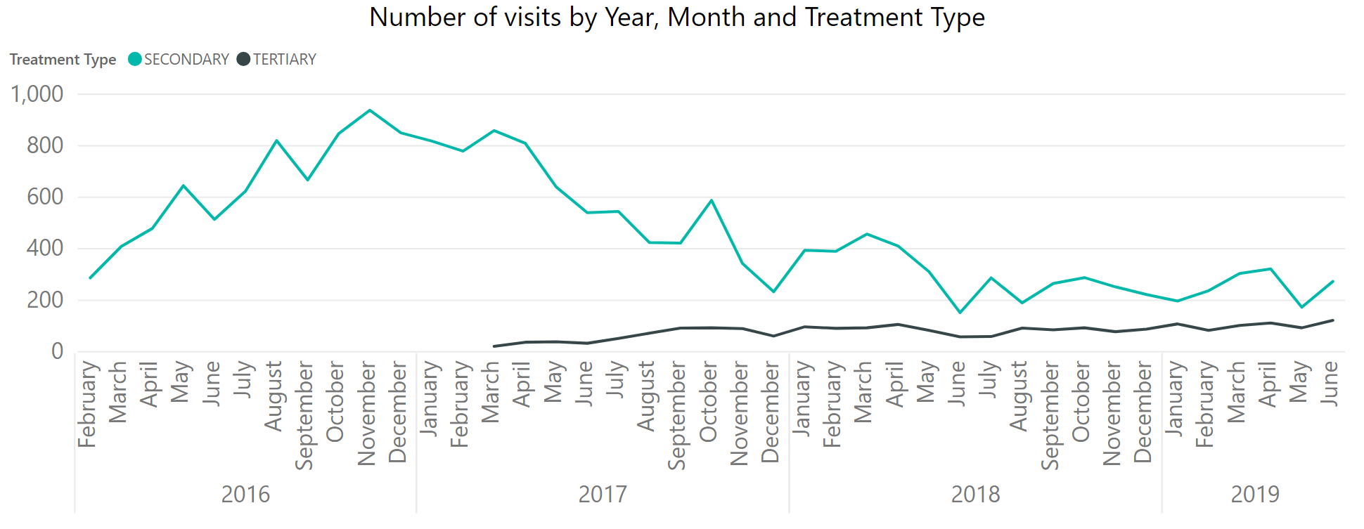
Till 30th June 2019, a total of Rs.293 million has been incurred in form of hospitalisation claims while ancillary payments of Rs.4.1 million have been incurred. The amount of claims per month for both secondary and tertiary health care services remains almost the same since July 2018. This means that higher cost tertiary healthcare services have increased value of claims even though the number of admissions as compared to secondary healthcare services was low.
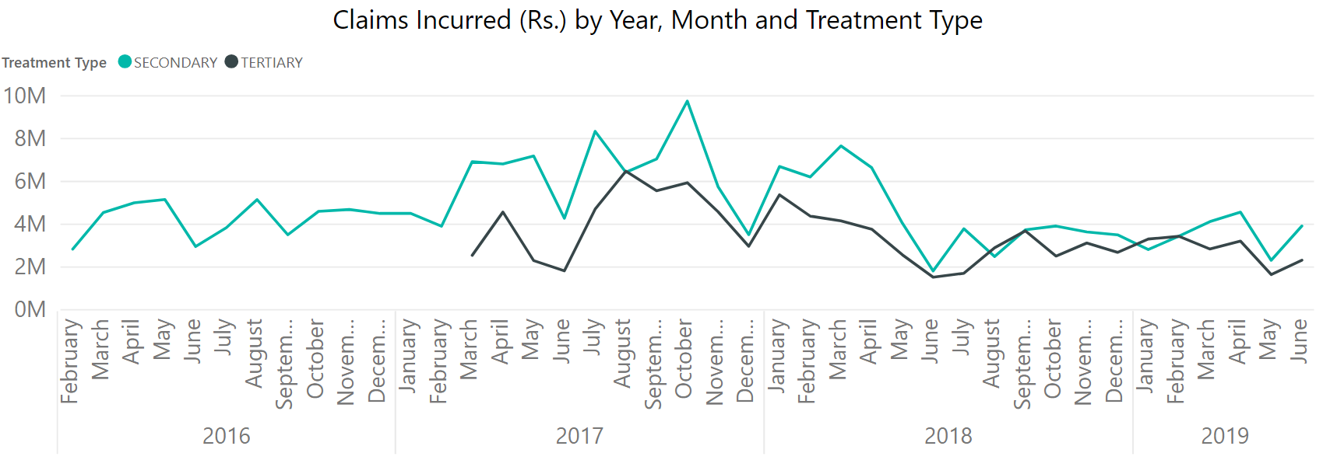
Since the introduction of tertiary health care services in the package, the highest amount of claims were for cardiology care cluster of treatments. The other type of cluster of treatments that has been given largest amount of claims is under the category ‘general surgery’.
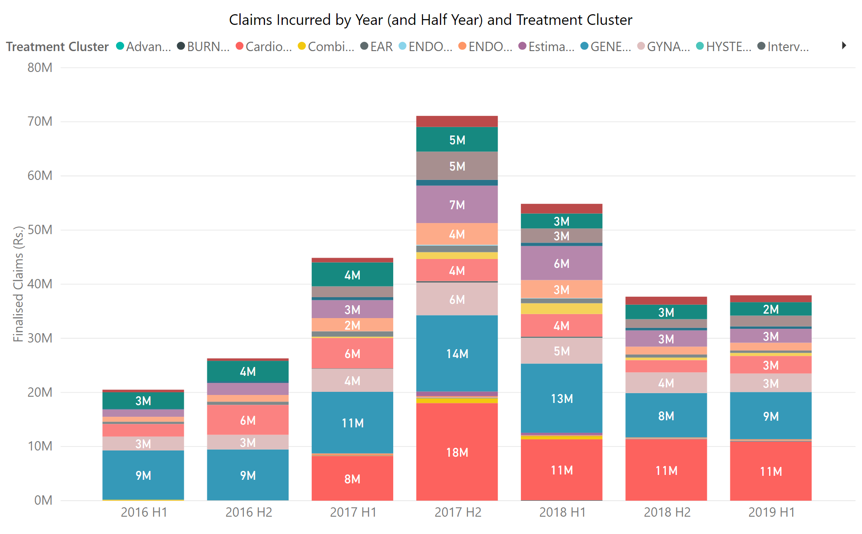
In terms of amounts, the total claims incurred in first half of 2019 were the same as second half of 2018. The claims incurred peaked in second half of 2017.
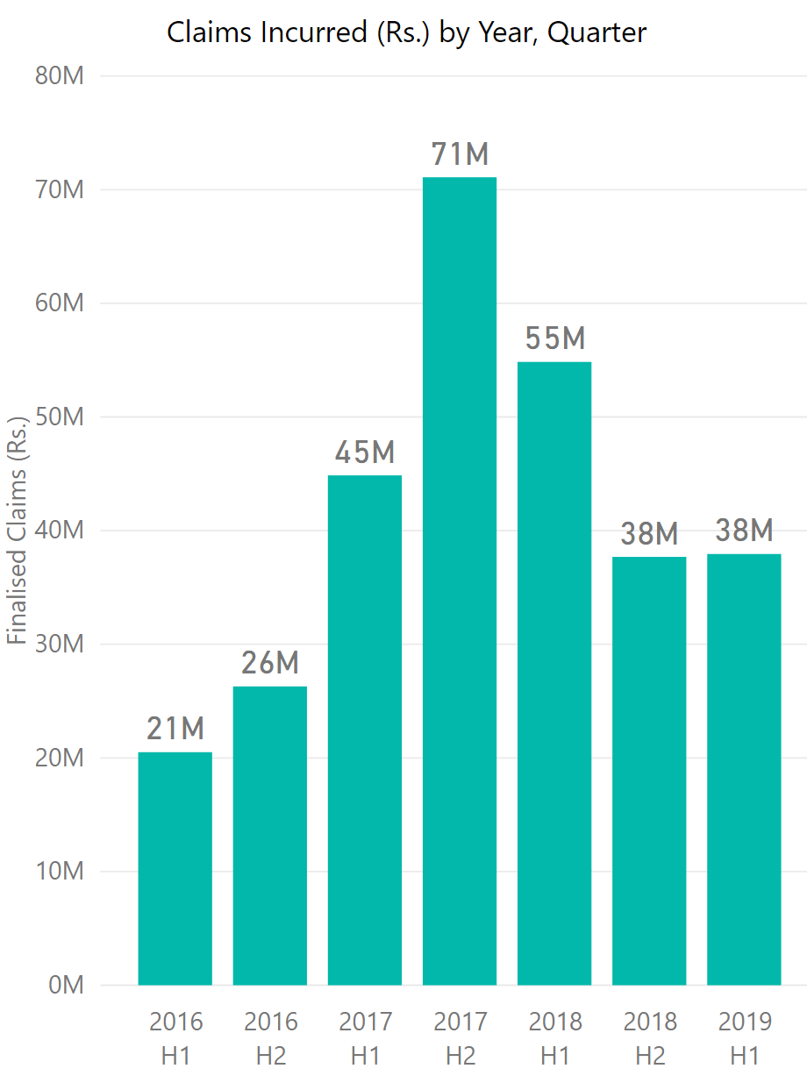
The individuals enrolled from the four districts use hospital services in different districts of the province.
Map 1 shows that the highest number of cases (both tertiary and secondary) was recorded in hospitals located in district Mardan. Darker colour shows highest number of admissions in comparison with total admissions.
Map 1: Admissions in different districts by individuals from four districts  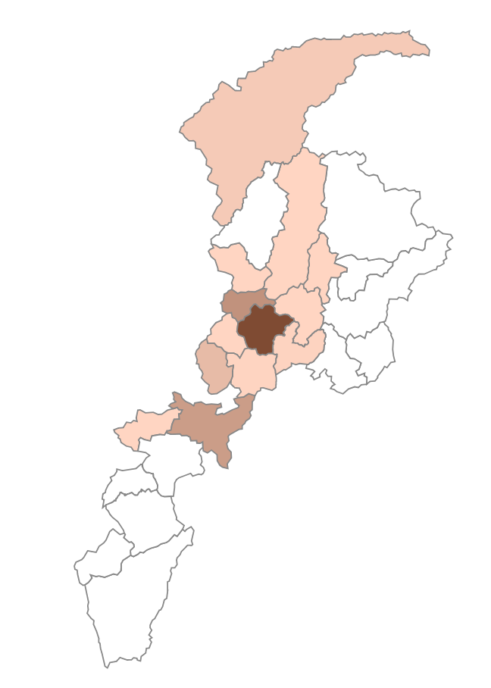 | Map 2: Admissions in different districts by individuals from Chitral  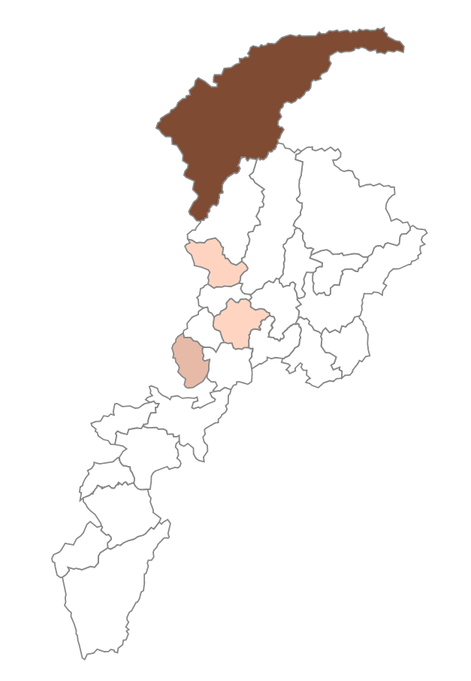 | Map 3: Admissions in different districts by individuals from Mardan  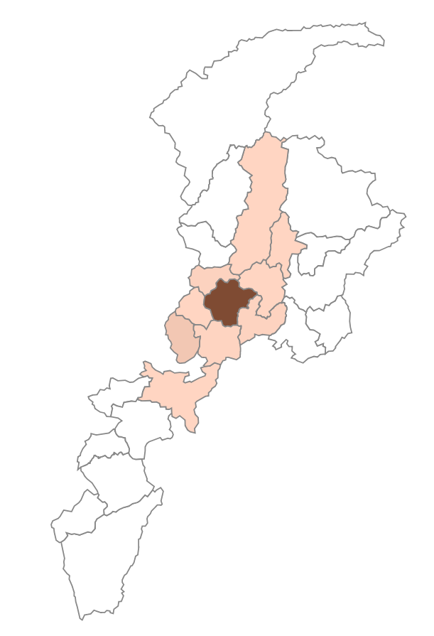 | Map 4: Admissions in different districts by individuals from Kohat  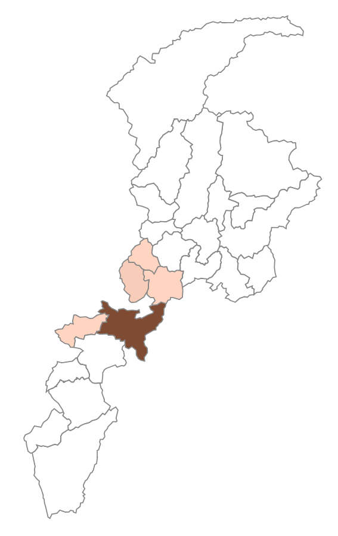

In terms of claims, the highest claims for tertiary health care services were incurred in hospitals located in district Peshawar. While for secondary care, the highest amount of claims was incurred in hospitals located in district Mardan.
Map 1: Tertiary services claims incurred  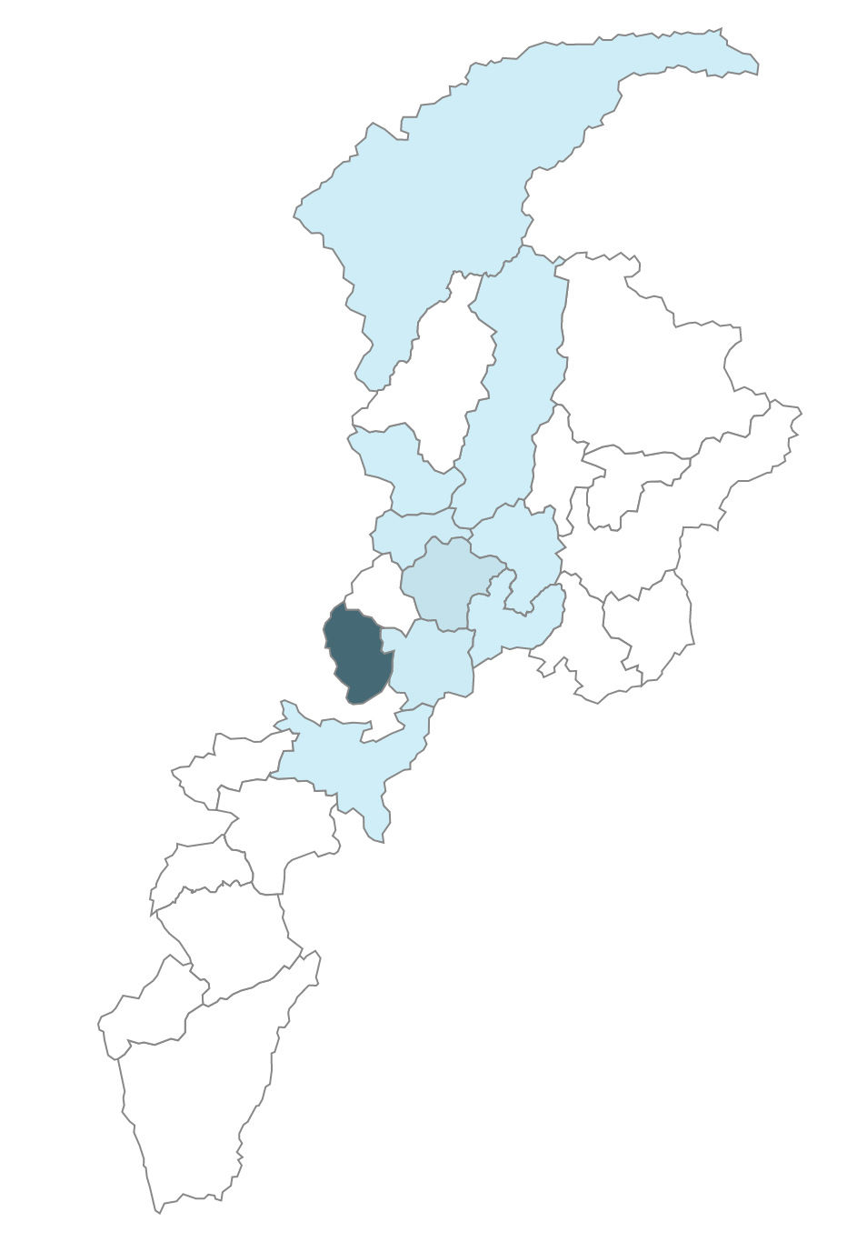 | Map 2: Secondary services claims incurred  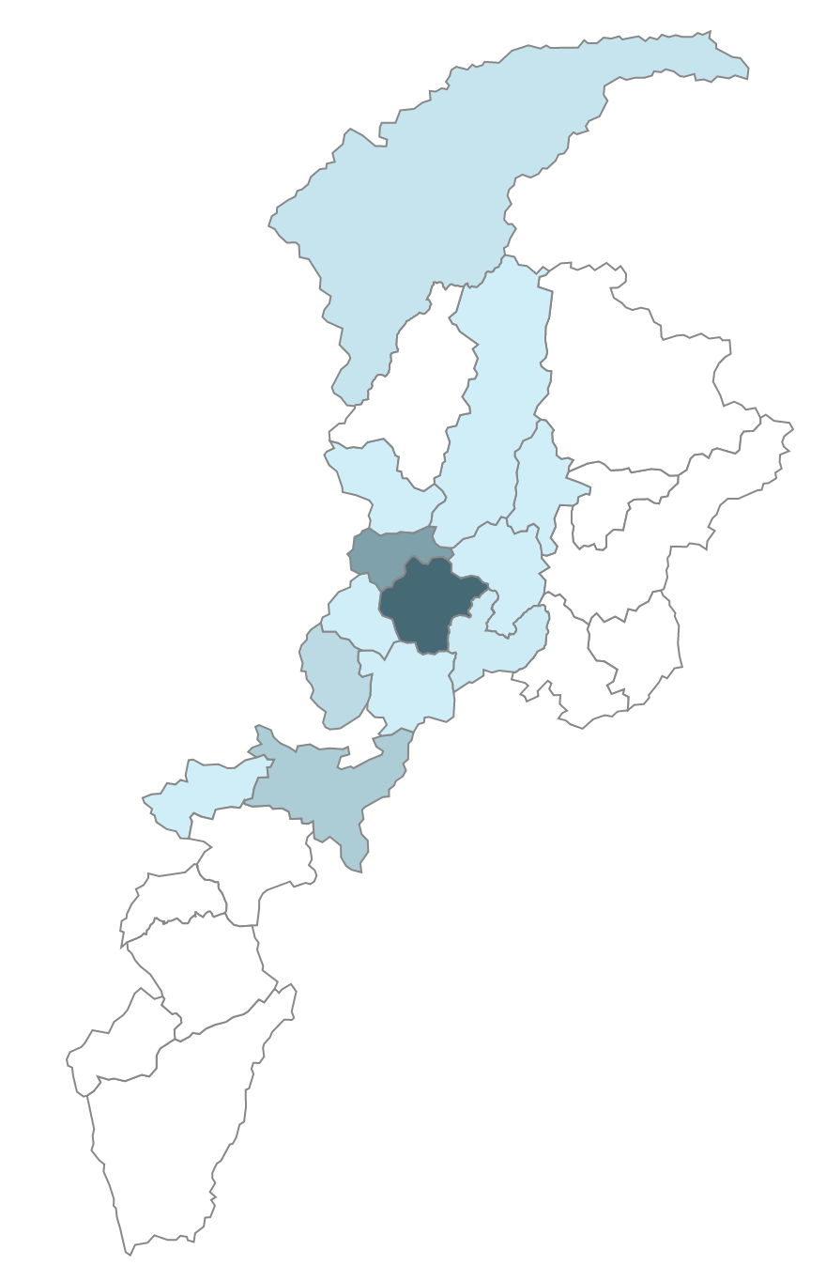

Utilisation Rates
Utilisation rates overall for the four districts was 0.3% in first half of 2019. As compared to 2018, this utilisation rate suggests that there is a likelihood that for the entire year of 2019, the utilisation rates for the four districts would match that of 2018.
In the first half of 2019 relatively better utilisation rates are noted in the district of Chitral, while comparatively low utilisation (as compared to 2018) was seen in the district of Malakand.
Table 5: Utilisation Rates (in %)
Utilisation Rates (%) | 2016 | 2017 | 2018 | 2019 (H1)
Chitral | 0.1 | 0.3 | 0.5 | 0.4
Kohat | 1.5 | 1.9 | 0.2 | 0.1
Malakand | 0.9 | 1.1 | 0.8 | 0.3
Mardan | 0.8 | 0.7 | 0.7 | 0.3
Cumulative (four districts) | 0.9 | 1.0 | 0.6 | 0.3

The incidence for various episodes leading to hospitalisation and thus “utilisation” of the insurance product in KP implemented by State Life Insurance has remained below 1%. KfW has been raising concerns that this is much below the initial estimates given in the design document of the scheme. Although the utilisation incidence in the design document was a broad estimate based primarily on international experience, the current utilisation of below 1% appears low. The utilisation rate in SHPI Phase-I in Gilgit district of GB managed by AKDN is around 2%.
The matter has been discussed with State Life Insurance Corporation, and data reviewed. SLIC maintains that the current utilisation rate is comparable with all the schemes in Pakistan including the National Health Insurance Program, the Health Insurance Program in Punjab and the Phase II of KP SHPI.
In addition, data related to other schemes implemented in Pakistan have also been reviewed by OPM team.
District | 2016 | 2017 | 2018 | SHPI Gilgit | NRSP Scheme | Punjab PMNHP | General population  Visits to health centres
Percent of insured individuals |  |  |  |  |  |  | During the reference period of two weeks prior to the date of interview 6.4 percent of the population in 2014-15 reported sick or injured. Khyber Pakhtunkhwa (KP) with 9.1 percent. This is ALL visits including outpatient visits.
Malakand | 1.04 | 1.38 | 0.92
Mardan | 1.04 | 0.84 | 0.87
Kohat | 0.8 | 2.27 | 0.24
Chitral | 0.11 | 0.36 | 0.71
Total | 0.7 | 1.2 | 0.7 | 2 | .44 (The number is for 2013; Jawad Rahmani informs me that it is 1.5%) | .56
Utilisation rates for some other schemes determined through review of literature are given in the table below:
In the RSBY scheme in India, the utilisation rate is estimated as .45% if we take into account the numbers below.
Current Status of RSBY Implementation in India 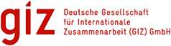
Cards issued – App. 35.3 million
People enrolled – Appr. 1222 million
Number of People benefitted till now – Appr. 5.5 million
www.rsby.gov.in 16.07.2013 SPeaigte 2

The issue of lower utilisation rate has been the subject of discussion in all the steering committee meetings as well as meetings with KfW. A number of possible explanations have been discussed including lack of awareness amongst the beneficiaries, access to service providers and possible impediments in access to treatment. OPM has suggested an intensive study of various factors which may also include household survey to find out the reasons, if any, for low utilisation. KfW has agreed to commission a study to determine causes of levels of utilisation and to provide recommendations for improvements in program implementation.

2019 Monthly Admissions
Month | Admissions | %age of Total Admissions
Jan | 455 | 18.59
Feb | 438 | 17.90
Mar | 505 | 20.64
Apr | 478 | 19.53
May | 368 | 15.04
Jun | 203 | 8.30
Total | 2447 | 100%

The sharp decline in May and June could be due to the Islamic month of Ramadan, in which people tend to avoid surgical procedures especially elective surgeries and mostly get admitted for emergency care.

Length of stay
One day admissions form almost 60% of admissions, taking into account all types of admissions. This could be attributed to the high proportion of surgical cases as generally, private hospitals admit many patients for surgical procedures in the morning operate them the same day and discharge them the next day.

No of Days | Admissions
1 | 1,363
2-3 | 660
>3 | 424

Length of stay (Non_surgical)
In non-surgical cases 75% of the patients had a length of stay of more than one day. And almost 40% were admitted for more than three days. Most of the non-surgical admissions take place at public hospitals, as private hospitals mostly provide surgical services and very few have medical specialists on their staff.

No of Days | Admissions
1 | 144
2-3 | 211
>3 | 230

Admissions by Type
Treatment Category | Admissions | % Total
Surgical | 1,642 | 61.10%
Gynae/Obs | 220 | 8.99%
Non-Surgical | 585 | 23.90%
Total | 2,447

The admission case mix is roughly 60% surgical case, rising from 50% in the last six months.

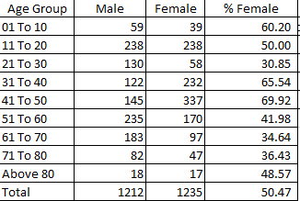
Age & Gender Wise Distribution of Admissions

There are two observations that are noteworthy from the age and gender distribution of admissions under the SHPI. First is that almost half of the admissions are for females, showing that access to services for women is encouraging. Second observation could is that very few children 10 years of age are being admitted under the SHPI. This has been investigated and this could be attributed to three factors;
- Number of children under 15 years of age enrolled in beneficiary households is low.
- Large number of hospitals visits for children under 15, usually are treated and managed as out patients care. If rehydration or observation is required, these are provided in small clinics or hospital stay is less than 6 hours and thus does not get recorded as admission.
- In many districts childhood illnesses requiring admissions are managed at military run hospitals, (especially in Mardan, Chitral and Kohat) which are not empanelled.

Treatments Provided

Top 20 Procedures
Procedure | Admissions
Non-Surgical | 461
Appendicectomy | 273
Tonsillectomy – Bilateral | 141
End Stage – Dialysis | 101
Hysterectomy – Abdominal | 83
Cataract With IoL | 76
Cholecystectomy and Exploration | 73
Coro Angiography with All Inclusive | 64
Hemorrhoidectomy | 47
Cataract (Unilateral) | 46
Normal Delivery | 42
Oncology | 35
Caesarean Delivery | 32
General Ward- Unspecified | 29
Asthma | 29
Hernia-Inguinal –Unilateral | 26
Septoplasty | 26
Open Reduction Internal Fixation (Large Bone) | 24
Hernia – Umbilical | 22
Cardiology | 21

Public Service Providers Utilization
Admissions Public vs. Private Hospitals
Districts | Public Hospitals |  | Private Hospitals |  | Total
 | Cases | Cost | Cases | Cost | Cases | Cost
Chitral | 209 | 2.64 | 15 | 0.58 | 224 | 3.22
Kohat | 81 | 3.00 | 91 | 3.09 | 172 | 6.09
Malakand | 234 | 5.95 | 331 | 6.99 | 565 | 12.94
Mardan | 637 | 9.20 | 849 | 19.6 | 1486 | 28.80
 | 1161 | 20.79 | 1286 | 30.26 | 2447 | 51.05

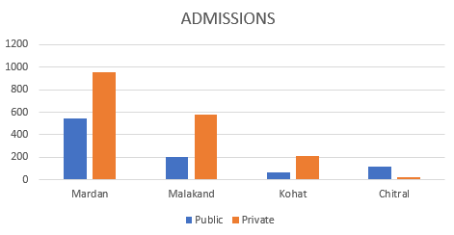
The Government Hospitals are increasingly taking market share of program The Government hospitals must still provide services comparable with the private sector, as measured by onsite visits as well as patient feedback.

Claims
State Life has a robust claims adjudication and payment model. Claims are currently processed in less than one month:
District | # Claim Submitted | Amount | # Claims Paid | Amount
Chitral | 177 | 3.01 | 72 | 1.77
Kohat | 186 | 6.20 | 124 | 3.74
Malakand | 547 | 12.66 | 332 | 7.37
Mardan | 1,476 | 28.89 | 885 | 18.47
Total | 2,386 | 50.77 | 1,413 | 31.37

Complaint Management
State Life has established a call centre for receiving complaints and forwarding to the concerned department for resolution. The call centre is also responsible for providing information to queries from beneficiaries.
Following is the list of common questions:
Nature of Calls | No of Calls
Addition of Hospitals | 42
Card Information | 1514
Duplicate card request | 8
Information about covered districts of KP SSP (Sehat Sahulat Program) | 410
Info about enrolment | 327
Information about KP SSP (Sehat Sahulat Program) | 508
information about members covered | 639
information about program and hospital | 903
information about state life | 48
information about treatment | 1408
New Baby Enrolment in card | 8
Panel Hospital Information | 3507
Test call | 18

Gate Keeping
State Life has implemented a four-tier gatekeeping model:
- Each hospital has a desk, staffed by a State Life employee (health facilitation officer - HFO) who screens the beneficiaries for identity and availability of funds in their accounts.
- Depending on the nature of treatment, they may be required to seek pre-authorization prior to admission from the District Medical Officers.
- District Medical Officers visit patient admitted in the empanelled hospitals within 24 hours of the admission to revalidate the identification of the patient, and eligibility of the treatment. The DMO may contest the case if the program parameters have not been met.
- The Provincial Medical Officer (PMO) has the overall responsibility of monitoring the team of DMOs. The PMO reviews contested cases, and works with the DMO and service providers to reach a settlement of such cases.

Steps to Improve Gate Keeping
- Lately a need has been felt for development of treatment protocols for various procedures for introduction of uniformity in performing a procedure among all the hospitals. This uniformity could also help in pricing and the gate keeping activity as well. A proposal for hiring of consultant is under consideration for development of treatment protocols.
- Proposal for hiring of a consultant is under consideration, who would develop training material related with the Treatment Protocol and would train the trainers of State Life for training of its HFOs, DMOs, PMOs and the Hospital Owners and Doctors.
- A new software program has been developed in house, which report various anomalies while processing the claims. It searches the database for any discrepancy, such as:
  - A patient having past admission of cataract bilateral and is admitted again for cataract.
  - A female having hysterectomy in past is admitted for delivery
  - A patient having past history of appendix removal is admitted again
  - A cataract admission with age in 0 to 40 brackets (for checking only, as sometimes the age is wrongly recorded)
  - Male maternity (for controlling the flow of wrong data)
  - Patient admitted but with missing treatments in database
- Proposal for hiring of cardiologist has also been approved for review and expert opinion on cardiology related procedures. A proposal is under consideration for establishing a committee of clinical specialists to provide expert opinion on clinical affairs and to provide their recommendations on disputes with hospitals related to claims.
- Arrangement of periodic refresher courses for HFO & DMO have been made for updating them on the changes introduced since their last training and use of IT tools developed from time to time.
- It has been made compulsory for all the DMOs to work in the claim processing department of the Project Office at Peshawar so that they could understand the processing part of the claims payment and send completed documents for quick processing.
- Admitted patients under the SHPI are followed up through telephone calls to verify claims and to get feedback on services provided.

IT tools for assisting claim processing
A range of tools has been developed for assisting the staff of the claims department. While referring to a particular admission a unique identity of visit number is used. The claims are a collection of different admission, and has a unique Claim number. There could be one to 20 visit numbers in one claim. And each claim is paid by a single cheque number.
Following is the different options (in blue on the sidebar) available to the claim department on their dashboard:

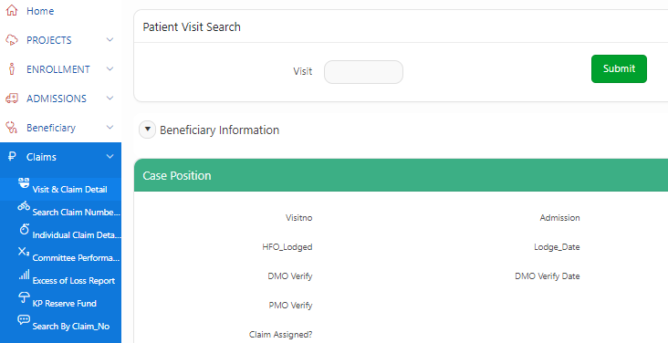

Visit & Claim Detail: This option allows search of any admission number in respect of its payment. It eliminates the physical handling of the record before or after the payment, while checking the status.
Search Claim Number: This helps the claim staff know the claim number under which a particular admission number is and this claim number could be further used for searching the status of the payment.
Individual Claim Detail: provides the detail of each claim paid or outstanding.
Committee Performance: The claims are checked by a committee of claim staff before payment is made. This committee is called ZCC (Zonal Claim Committee). For approval purpose, each claim is checked in a meeting of members not less than three (out of which one must be a doctor, one from the Accounts and one from Claim Processing department). A ZCC meeting is held on daily basis for approval of the claims. There could be more than one committee. The Committee Performance shows the activity conducted by each committee between any time period.

Organisational Development

Part 2: Gilgit-Baltistan

The overall approach of the Social Health Protection Initiative in Gilgit Baltistan
Government of Gilgit Baltistan, with financial support of Government of Germany through KFW, is implementing a health insurance scheme in Gilgit District under the Social Health Protection Initiative Pakistan (SHPI). The goal of this initiative is to contribute in reduction of financial hardship of the poorest families of the district through providing them access to quality assured hospital services on cashless basis, as research has shown that availing these services push poorer families into further poverty. The specific objectives of this scheme are to:
- Reduce catastrophic and out of pocket health expenditures of the 21% poorest families in Gilgit district
- Improve in health status of the population of the district through improved quality of care and access to secondary health care services.
- Improve health seeking behaviour amongst the target population through awareness raising and community mobilisation.
- Promote the product among the general population by targeting the enrolment of 29% of the population by the end of 5 years thereby contributing in promoting alternate health financing mechanism
Under SHPI a Micro Health Insurance (MHI) scheme is being implemented that entails compulsory enrolment of 21% of the poorest families in programme district as per the Poverty Means Testing (PMT) scores maintained by Benazir Income Support Programme (BISP). The cut-off PMT score of poorest 21% of population of Gilgit district is 16.17. The premium of this population is paid by the Department of Health GB out of the programme funds created by KFW and Government of GB, the share of the later is being scaled up annually from the initial 5% contribution as a step towards long term sustainability of the scheme. In addition to increasing the contribution of Government of GB share in payment of premium payment, another important step taken in the design of the scheme for long term viability is mandatory enrolment of 29% population of the programme district amongst population with PMT scores of above the cut-off value over the life of the project.

Aga Khan Development Network (AKDN) Consortium, comprising Aga Khan Foundation Pakistan, Aga Khan Rural Support Programme and Jubilee Life, is implementing the scheme of MHI in Gilgit District under a contract with DOH-GB for five years since August 2016.

Programme Area and Population
The scheme of MHI under SHPI is being implemented in Gilgit district of GB. Gilgit district consists of 11 union councils and one Municipal Committee, spread over an area of 4,208 square kilometres with a population of 193,100, at the time of signing of contract in 2016 residing in 26,095 households.
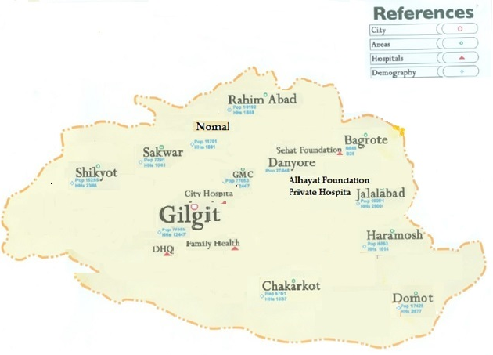

Figure 5: Map of Gilgit District with its Union Councils

Compulsory Enrolment: As per contract between DOH-GB and AKDN consortium, the unit of enrolment for insurance is ‘household’ with a maximum of ‘seven’ members. The total number of households in 21% of the poorest population in Gilgit district is 5,480. These households are termed as eligible household and their enrolment is mandatory for the project implementing organisation - AKDN. BISP data was used to identify and enrol eligible households using PMT scores; the cut-off value of the poorest 21% house is 16.17. The insurance premium of these eligible households is being paid by DOH out the programme funds committed by KFW and Government of GB. AKDN used a mulita-pronged strategy to reach and locate the households. AKRSP being an organisation having extensive links with community-based forums like Village Organisations, Women Organisations and LSOs/CSOs was tasked to locate, enrol and deliver insurance cards and MHI related awareness material.
Voluntarily Enrolment: In addition to compulsory enrolment of ‘eligible’ households, AKDN, under the contract, is bound to enrol 29% of households from the remaining population 79% with PMT scores of above 16.17 over a period of five years. Enrolment for this section of population is called as “wider enrolment”. Jubilee Life with the help of AKRSP marketed an MHI product for wider enrolment to be purchased by households for their members.

Key Highlights of the Reporting Period

Expanding coverage of insurance in Gilgit District under SHPI:
After decision of Federal Government to roll out National Health Insurance under ‘Sehat ka Insaf” programme to all districts of Gilgit Baltistan (GB), Government of GB decided to expand coverage of health insurance under Social Health Protection Initiative (SHPI) Phase-2 in Gilgit district with financial cooperation of Government of Germany through KfW. The coverage will be expanded both in terms of population covered and benefits package offered. The coverage of eligible population will be enhanced from PMT below 16.17 to 32.5 which will translate into increasing population covered from 21% to approximately more than 50% of population of Gilgit district. The benefit package will also include tertiary level care. KFW has also agreed to support this enhancement of population and benefits coverage.
Oxford Policy Management’s technical support played a pivotal role in reaching this decision. OPM assisted DOH GB and KfW in analysing different options for the way forward of SHPI in GB through carrying out and presenting detailed ‘Options Appraisal’ including financial implications, arranging meetings for DOH-GH and KFW with different stakeholders including Chief Minister GB, federal Ministry of National Health Services, Regulations and Coordination. This decision of GB Government for opting implementing KFW co-financed SHPI health insurance instead of National Health Insurance in Gilgit District has been formally communicated to the Federal Government by DOH.
It has also been agreed that Jubilee Life will continue providing services as per the contract between DOH and AKDN Consortium for already covered population. For additional population and benefits package there will be a fresh tendering and during the reporting period OPM drafted and submitted to DOH-GB the Request for Proposal for hiring an insurance organisation for proving these additional services. DOH GB has initiated developing PC-1 for phase 2, OPM will provide technical support in finalising the PC-1.
Ms Marlis Sieburger, Head of Division, KFW Frankfurt visited Gilgit on 8 May 2019 and met with DOH-GB and PMU officials, OPM team and Chief Minister GB to discuss the progress of MHI scheme under SHPI and its future in GB. During her meeting with Chief Minister GB, Ms. Sieburger principally agreed with option of transfer funding from Phase-II to current phase of SHPI in GB, provided higher authorities of KFW at Frankfurt endorse it. She also agree that after approvals the coverage of scheme will be increased from 16.17 to 32.2 PMT scores and benefit package will also include tertiary care for the insured eligible households. She asked DOH-GB to send a formal letter to KFW in this regard.
On request of DOH-GB, KfW formally conveyed its willingness to transfer additional funding from Phase-II of SHPI to the current phase for enhanced population and benefit coverage in Gilgit district as well Technical Support provided by OPM.

SHPI Related Initiatives by government of GB

Chief Minister Health Endowment Fund Gilgit Baltistan
Absence of a tertiary care facility for treatment of the fatal diseases, a large distance from specialized care hospitals and lack of affordability to get treatment from tertiary care hospitals justifies establishment of an endowment fund to help poor patients of Gilgit-Baltistan.
In order to cater for the needs of poor patients for specialized care in tertiary care hospital across the Pakistan a Chief Minister’s Health Endowment Fund (CMHEF) has been established for the people of Gilgit-Baltistan initially amounting to Rs 700 Million. The said fund is proposed to be placed in the GL of Health Department under separate Head of Account named Health Endowment Fund.
The Fund is proposed to be used for the following categories’ to help poor /deserving patients of GB.
- The patients suffering with Malignancies of any sort except CML.
- Organ Transplant e.g. Liver, Kidney and Bone Marrow transplantation.
- Patients below poverty level testified by the office of Deputy Commissioner of the District or BISP list.
- Patients registered under the social Health Protection (SHP) and Prime Minister National Health Program (PMNHP), beyond their insurance coverage.
- The patients referred by the PMNHP or the SHP, the program after verification will send the documents to the CMHEF Program Management Unit which will be processes as other cases.
  - Bidding process to hire a Scheduled Bank is under process and will be finalized soon.
  - After the selection of Bank the patients will be facilitated through endowment fund.

Initiation of Exit Interviews of Beneficiaries
Project Management Unit GB initiated conducting exit interviews of beneficiaries from eligible population admitted in hospitals in order to get information about the experience of the services provided through Health Card of Social Health Protection Initiative. The interview forms were placed at empanelled hospitals and discharged beneficiaries were asked to fill the form. The exit interview focuses on various areas including awareness level, level of beneficiary satisfaction from services provided, behaviour of health facility staff etc.

Project Update

Population Coverage

Population Eligible for enrolment in government/KfW funded SHPI
The total number of households eligible for enrolment in Gilgit district, according to the contract signed between DoH and AKDN, is 5,480. AKDN consortium has succeeded to identify and enrol 5,340 households from 11 union councils including Gilgit Municipal Committee area. The table below gives a detailed picture of enrolment by each Union Council\locality.
Table 5: Status of enrolment of eligible households by each Union Council (June 2019)
Sr.# | Name of UC | Target | Achieved | Percentage achieved
1 | Bagrote | 267 | 332 | 124%
2 | Chakarkote | 453 | 422 | 93%
3 | Damote | 1050 | 969 | 92%
4 | Danyoure | 362 | 302 | 83%
5 | Gilgit Municipal Area | 1182 | 1035 | 88%
6 | Haramosh | 363 | 363 | 100%
7 | Jalalabad | 538 | 525 | 98%
8 | Nomal | 180 | 245 | 136%
9 | Rahimabad | 219 | 326 | 149%
10 | Sakwar | 240 | 231 | 96%
11 | Shekayute | 626 | 590 | 94%
Total |  | 5,480 | 5,340 | 97%

Enrolment amongst Wider Population
AKDN strives to enrol households from wider population through community meetings, awareness sessions and dialogues with LSOs/SCOs. During the reporting period these efforts continued and 135 new households purchased the insurance products.
The following table shows the trend of wider enrolment in Gilgit district:
Table 6: Progressive trend of wider enrolment in Gilgit district (Jan 2017-Jun 2019)
Period | Household Enrolled | Population | Cumulative Household Enrolled | Cumulative Population | Achievement against Target (7567 HHs)
Jan-Dec 2017 | 733 | 4142 | 733 | 4142 | 10%
Jan-June 2018 | 2422 | 10928 | 3155 | 15070 | 42%
July-Dec 2018 | 2015 | 10014 | 5170 | 25084 | 68%
Jan-June 2019 | 135 | 358 | 5305 | 25442 | 70%

The following table shows the updated status of enrolment amongst eligible population and wider enrolment against the set targets in the contract between DOH-GB and AKDN Consortium.

Table 4: Status of Enrolment of Households (June 30, 2019)
Enrolment: Target vs. Achievement
District: Gilgit | Target |  | Achievement |  | Percentage Achieved
 | Households | Population | Households | Population
Insured from eligible population | 5480 | 38360 | 5340 | 35671 | 97%
Insured from wider population | 7567 | 52973 | 5305 | 25442 | 70%

Coordination and Review Meetings
Frequent and regular coordination meetings were held at the field level in Gilgit on a monthly basis, with representations from OPM, DoH-GB, AKRSP, JLI and other relevant stakeholders, to ensure smooth implementation of planned activities, and to flag any arising concerns or resolve any foreseeable issues or bottlenecks in implementation of upcoming activities. As and when required, Review meetings were held at the Head Office Level in Islamabad, with representation from senior management of AKDN Consortium, DoH-GB, OPM and KfW.

Social Mobilisation and Marketing Activities

Social Mobilisation
To ensure community mobilisation and promotion of Micro health Insurance, AKRSP is regularly organising community events including meetings with LSOs/CSOs, community support groups and managers of community-based forums like Village and Women Organisations. During the reporting period a total of 212 people (66 male and 162 female) participated in these meetings. The following table provides details of community mobilisation sessions:
Table 7: Community mobilisation and MHI promotion activities
Sr.No | Name of LSOs/CSOs | Male | Female
1 | Rahimabad Local Support Organization | 10 | 18
2 | Nomal Local Support Organization | 5 | 20
3 | Village and Women Organisation Danyour | 8 | 30
4 | Sakwar Youth Organization | 9 | 25
5 | Damote Development Organization | 10 | 6
6 | Barmas Women Organisation | 0 | 25
7 | TADO | 10 | 0
8 | Women Organisations | 0 | 20
9 | Pakiza Welfare Organization | 5 | 0
10 | Karakorum International University | 9 | 18
Total |  | 66 | 162

In order to promote MHI product orientations pamphlets and broachers were given to participants. Moreover, Insurance Forms were distributed to Managers to ensure maximum wider enrolment. At the end of each meeting questions and answer session were arranged for brining clarity about the insurance scheme.

Figure 6: Glimpses of a Community Mobilisation Session
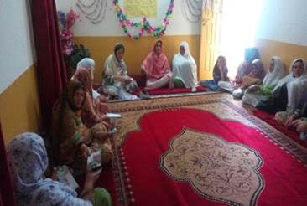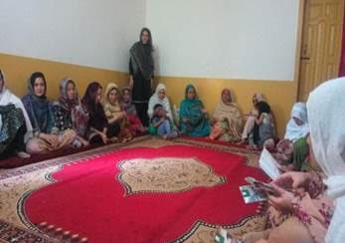

Marketing Activities
During the reporting period, AKRSP signed a contract with Radio Pakistan Gilgit, as per the contract the Radio Pakistan Gilgit will carry out marketing campaign for three months in local languages. The radio campaign will be focused on the marketing of the products for wider enrolment. Information, Education and Communication (IEC) material containing brochure, envelops, standees have been printed and placed at vicinity of empanelled hospitals. In addition, during the distribution ceremony of Sehat Hifazat cards Government health sector representatives were invited to take part. Project has conducted several sensitisation workshops with key influencers, men and women groups and support groups for creating awareness about the health insurance scheme. The support groups were encouraged to plan and implement the one-to-one home visits in project catchments area and promote the health insurance literacy.

Stakeholders meetings
During the reporting period three coordination meetings were organised with the partners to share the SHPI progress and issues of wider enrolment. These meetings were attended by representatives from Oxford Policy Management, Aga Khan Foundation, AKRSP and Jubilee Life. In the meetings partners discussed the emerging issues about enrolment, distribution of health cards, development, printing and dissemination of communication material, complaints management, claims settlement and coordination with Department Health were also discussed.
To overcome the wider enrolment issues the partners agreed upon that a door to door mobilisation with the assistance of V/WOs is much needed, while, awareness campaigns through electronic and print media, local cable, newspaper and local FM Radio were also recommended for further mobilisation.

Service Delivery
During reporting period (January to June 2019) there were total 1030 admissions including 687 (67%) admissions from wider enrolled population and 343 (33%) admissions from eligible households. In total 1030 admissions, 67% were female patients.
Among the admitted cases 48% (498) were reported to be surgical cases, 49% (500) non-surgical cases and 03% (32) maternity cases.
The top ten causes of hospital utilization are given below in the table.

Table 8: Top 10 Diagnosis of admitted cases (Eligible and Wider enrolment) Jan-Jun 2019
Diagnosis (as per ICD coding) | Total
 | Number | % of all cases
Appendicitis, acute w/o peritonitis | 175 | 17.0%
Upper respiratory infection, acute, NOS | 87 | 8.4%
Urinary Tract Infection, unspec./pyuria | 42 | 4.1%
Pregnancy care, other complications, | 36 | 3.3%
COPD | 34 | 3.1%
Fever, unspecific | 34 | 3.1%
Gastroenteritis, infectious | 30 | 2.9%
Septicaemia, gram-negative, unspecific | 28 | 2.7%
Gastritis, unspecific w/o haemorrhage | 23 | 2.1%
Hypertension, benign | 23 | 2.1%

Quarterly Admissions

Figure 8: Quarterly trend of Admissions (Jul 2018 to Jun 2019)

The trend of quarterly admissions shows an increasing trend since inception of SHPI, however it may be due to increasing population. For this reason quarterly utilisation ratios are used to show average quarterly number of visits per 100 insured person in the following graph.

Figure 9: Average number of quarterly visits by 100 insured persons

The above graph depicts the average number of visits per 100 insured persons on quarterly basis. This ratio also shows an increasing trend since Quarter 1 2018 with slight variation.

Admissions in Hospitals
The following data shows admission numbers in different empanelled hospitals.
Gilgit Medical Centre (GMC) recorded the highest number of admissions cumulatively. However vast majority of admissions were for people insured under the voluntary purchase “Wider Enrolment” scheme. Only 18 of the 661 admissions under SHPI were for patients enrolled as beneficiaries with premium being paid by government/KfW.
Conversely, very large proportion of admissions for the government/KfW funded beneficiaries get admissions in public sector City Hospital and DHQ hospitals. also take the massive burden of patients from eligible population, as being economical secondary healthcare facility and attractive for eligible admissions, The Sehat Foundation Hospital, as well as the Family Health Hospitals, both non profit hospitals run by non government organisations get a negligible number of patients.
Numerous rounds of discussions have been held between DoH staff, JLI, AKRSP and AKF staff and OPM consultants on possible reasons for the use of different hospitals by different segments of the population. One possible reason could be that many purchasers of health insurance under the Wider Enrolment scheme are those who have experience of health insurance in the past. Those health insurance schemes were offered by Jubilee Insurance and AKHS,P run health facilities in Gilgit were the main service providers. Public sector hospitals were not on panels for these schemes. Population insured under the voluntary scheme are therefore better informed and use the Gilgit Medical Centre, managed by AKHS,P. GMC is generally considered to offer better quality services and also is considered as expensive. People insured under the government funded scheme are using the public sector hospitals due to either familiarity with the DHQ and City hospitals or they lack information on GMC being on the panel of hospitals under SHPI.
148 admissions were reported in the non-panelled hospitals within and outside of Gilgit district due to broader understanding among JLI and service providers, mostly AKHS,P facilities in Aliabad, Gupis and Singal. Such arrangement is important because Gilgit town residents have houses in other districts also.

Table 9: Admissions in each Hospital (Jan-Jun 2019)
Admissions |  |  | Total | Percentage
Hospital | Wider | Eligible
Gilgit Medical Center | 643 | 18 | 661 | 64%
City Hospital | 19 | 188 | 207 | 20%
DHQ | 10 | 132 | 142 | 14%
Sehat Foundation Hospital | 1 | 5 | 6 | 1%
Family Health Hospital | 2 | 0 | 2 | 0%
CMH Gilgit | 12 | 0 | 12 | 1%
Total | 687 | 343 | 1030 | 100%
The hospital admissions data show that for the eligible population, there are generally more females making use of both public and private healthcare, though the vast majority of women use public healthcare facilities. Public healthcare is also more attractive for men among eligible group, while only 6 use private facilities.

Type of Hospital | Eligible |  | Wider |  | Total | Percentage
 | Male | Female | Male | Female
Public | 81 | 239 | 10 | 19 | 349 | 34%
Private | 6 | 17 | 248 | 410 | 681 | 66%

As for the wider population, females are much more likely to use private facilities, 410 women as opposed to the 219 make use of them, and the same is reflected in the men (248 vs. 10).

Age and Gender Distribution by eligible and wider enrolled
During the reporting period 67% admissions were of the female clients of different age group. Among that, 42% of female clients belong to reproductive age group. The following table shows the distribution of different age groups.

Table 10: Distribution of admissions by Age group, gender and type of enrolment
Age Group | Male |  | Female |  | Total |  | Percentage
 | Wider | Eligible | Wider | Eligible | Male | Female | Male | Female
Less than 1 | 24 | 5 | 26 | 6 | 29 | 32 | 8% | 5%
Under 5 yrs. | 34 | 12 | 38 | 14 | 46 | 52 | 13% | 8%
5 to 10 yrs. | 21 | 15 | 27 | 12 | 36 | 39 | 10% | 6%
11 to 18 yrs. | 22 | 27 | 35 | 88 | 49 | 123 | 14% | 18%
19 to 29 yrs. | 15 | 4 | 66 | 23 | 19 | 89 | 6% | 13%
30 to 39 yrs. | 14 | 4 | 72 | 38 | 18 | 110 | 5% | 16%
40 to 49 yrs. | 36 | 6 | 46 | 43 | 42 | 89 | 12% | 13%
50 to 59 yrs. | 23 | 4 | 32 | 21 | 27 | 53 | 8% | 8%
60 to 69 yrs. | 26 | 7 | 40 | 6 | 33 | 46 | 10% | 7%
70 to 79 yrs. | 27 | 2 | 33 | 3 | 29 | 36 | 8% | 5%
80 yrs.& above | 16 | 1 | 14 | 2 | 17 | 16 | 5% | 2%
Total | 258 | 87 | 429 | 256 | 345 | 685 | 100% | 100%

Length of Stay
During the reporting period, out of 1030 admissions (687 wider and 343 eligible), 27% of patients stayed for 1 day or less, 64% of patients stayed 2-3 days, and 9% of patients stayed for longer than 3 days.
The length of stay in government hospitals had an average of 3 days, whereas the length of stay in private hospitals was 2 days.

Table 11: Average length of stay by each hospital (Jan-Jun 2019)
Hospital | Average Length of Stay
 | Eligible | Wider
City Hospital Gilgit | 4 | 3
District Head Quarter | 4 | 2
Gilgit Medical Center | 2 | 3
Sehat Foundation Hospital | 2 | 1
Family Health Hospital | 0 | 1
Non-Panel | 0 | 2
Overall Average | 3 | 2

The table above shows that the average length of stay for clients from eligible population was 3 days, and patients from wider enrolment stayed for an average of 2 days.

Claims Settlement
The eligible and wider population claims detail illustrated in the given table below. The total cost for the eligible citizens is 2,252,438 rupees for women and 2,998,838 rupees for men. The total cost of the wider population of women is 5,910,492 rupees and 9,840,157 rupees for men. Average claim amount for wider enrolment reported 14,323 rupees and 8,743 rupees for eligible population.
Table below summarises the claim settlement for the eligible enrolment during reporting period.

Table 12: Claims settlement pertaining to patients from eligible HHs
Hospital | # of Claim Submitted | # of Claims Settled | Amount paid (PKR) | Average (PKR)
Aga Khan Medical Centre Gilgit | 18 | 18 | 289,156 | 16,064
City Hospital | 188 | 188 | 1,670,769 | 8887
DHQ | 132 | 132 | 947,692 | 7179
Sehat Foundation Hospital | 5 | 5 | 91,221 | 18,244
Total | 343 | 343 | 2,998,838

Average amounts of claims for public sector hospitals are almost half of the private/non-government hospitals.
Table below shows the claim settlement for the wider enrolment during reporting period by each health facility.

Table 13: Claims settlement pertaining to patients from wider enrolment
Hospital | # of Claim Submitted | # of Claims Settled | Amount paid (PKR) | Average (PKR)
Aga Khan Medical Centre Gilgit | 643 | 643 | 9,279,698 | 14,431
City Hospital | 19 | 19 | 119,634 | 6296
DHQ | 10 | 10 | 60,865 | 6086
Sehat Foundation Hospital | 1 | 1 | 24,000 | 24,000
Family Health Hospital | 2 | 2 | 24,000 | 12,000
Combined Military Hospital Gilgit | 12 | 12 | 331,960 | 27,663
Total | 687 | 687 | 9,840,157

Overall the highest revenues were generated through providing services to insured patients under SHPI by Aga Khan Medical Centre Gilgit (PKR 9,568,854) followed by City Hospital Gilgit (PKR 1,790,403) during the reporting period. The share of public sector hospitals (including CMH) was 24% compared to 76% by private sector hospitals.

Complaint Management
There are three channels for enrolled population to lodge complaints. Customers can send complaint at Jubilee Health’s email address, drop complaints and comments in the complaint boxes or call the helpline. Trained staff is deployed to manage the complaints 24 hours a day.
During the reporting period, comments and complaints were received about inclusion of OPD services in the benefits package, enhancement of inpatient hospital coverage limit, inadequate cleanliness and unhygienic environment at hospital and attitude of medical staff at hospital.
A complaint response mechanism has been established at all panel hospitals. The complaint boxes, in hospitals, are opened on weekly basis by a team comprising hospital administration and JLI facilitation desk staff. Further the JLI team analyses the complaints and processes it for timely action to ensure better facilitation of the patients.

Financial summary of OD funds utilisation:

For Jan – June 2019
AKDN Contribution (OD funds) (2016-2020): | Pak Rs. 20,685,500
b. Total OD expenditure incurred to date: | Pak Rs. 18,042,713
i. From Programme funds: | Pak Rs. 12,849,441
ii. From HIO’s resources: | Pak Rs. 5,426,272
c. OD expenditure during reporting period (Jan - Sept 2018): | Pak Rs. 9,152,083
OD funds allocated for next quarter: | Pak Rs. 3,000,000

a. Total Committed Amount (KfW) (2017-2018): Pak Rs. 29,970,000
AKDN Contribution (OD funds) (2016-2020) : Pak Rs. 20,685,500
b. Total OD expenditure incurred to date: Pak Rs. 23,060,722
i. From Programme funds: Pak Rs. 16,870,677
ii. From HIO’s resources: Pak Rs. 6,190,045

Financial Report Jan. – June 2019, SHPI Gilgit & Khyber Pakhtunkhwa
The program is in the 4th year in Khyber Pakhtunkhwa and 3rd year in Gilgit Baltistan. Details of the program funds disbursement is as follows.
- In KP premium for the 4th year was disbursed in December 2018 on the basis of old rates of premium with the understanding that the balance amount of premium, if any, would be paid to SLIC after the premium is approved by DoH/KFW. Since the Phase-II agreement had come to an end and the process for selection of Implementing Organization was likely to take 3-4 months it was decided that SLIC will be asked to continue providing services to the beneficiaries till the selection process for the next phase of the scheme is completed. SLIC quoted annual premium of PKR 2250 per family/HH.
The Steering Committee in its meeting dated 21st January 2021 agreed to the premium quoted by SLIC for a period of six months for both Phase-I and Phase-II of the scheme. The premium quoted by SLIC was communicated to KFW on 20th February 2019 by DoH for its N.O. KFW asked for actuarial assumptions/basis of the quoted premium which was provided and then an options paper was sent to KFW on 23rd March 2019 and certain queries raised were responded to but KFW neither issued an NO letter nor raised the issue thereafter. DoH on the other hand paid its premium for the Phase-II beneficiaries for 6 months @ PKR 2250/family. Since SLIC was successful in the tendering process further payment for the period 1st July 2019 to 31st December 2019 will be paid @ PKR 2000/family. The following three situations could emerge regarding KP premium for the 4th year.
- Decision taken by the steering committee is agreed to by KFW on the basis of justification for the increase provided by SLIC, premium of PKR 2250 per Household will be paid for the period of 6 months and PKR 2000/ HH for the remaining period of 6 months. Financial implication of this decision would be as follows.
PARTICULARS | First Half | Second Half
Number of HHs | 95405 | 95405
Premium PKR | 2250 | 2000
Annual Premium | 214661250 | 190810000
KFW share 80% | 171729000 | 152648000
Euros @ 165 | 1040781.82 | 925139.39
Half yearly | 520390.91 | 462569.70
Total | 982960.61
Already disbursed | 675681.97
Balance Payable | 307278.64

- KFW does not agree with the justification for increase in premium and decides to pay its share of premium at the existing annual premium of PKR 1500 per Household for the entire year. Financial implication of this decision would be as follows.
PARTICULARS | AMOUNT
Number of HHs | 95405
Premium PKR | 1500
Annual Premium | 143107500
KFW share 80% | 114486000
Euros @ 165 | 693854.55
Already disbursed | 675681.97
Balance Payable | 18172.57
- KFW does not agree with the justification for increase in premium and decides to pay its share of premium at the existing annual premium of PKR 1500 per Household period of six months and PKR 2000 for the remaining period of six months to bring the premium and the benefits package in line with the KP government scheme. Financial implication of this decision would be as follows.

PARTICULARS | First Half | Second Half
Number of HHs | 95405 | 95405
Premium PKR | 1500 | 2000
Annual Premium PKR | 143107500 | 190810000
KFW share 80% | 114486000 | 152648000
Euros @ 165 | 693854.55 | 925139.39
Half yearly | 346927.27 | 462569.70
Total Euros | 809496.97
Already disbursed | 675681.97
Balance Payable Euros | 133815.00

The calculation of premium in the financial chart showing expenditure and savings is being done on table a above being the highest amount.

- In GB Premium for 3rd year has already been paid to AKDN. Premium for the 4th year will become due in September. Premium due for the 4th as per original contract is Euros 37350. But since KFW has agreed to the revised premium of PKR 2300/HH/Annum, DOH GB will be submitting amendment to the contract to the extent of premium for NO letter from KFW. On the basis of the revised premium an amount of Euros 56146 will be paid to AKDN. Besides an amount of Euros 4360 will be paid to AKDN on account of 10% withheld for wider enrolment.
- Calculation of the premium is as follows.
Premium Payment in 4th year
Number of household | 5,340
Premium per household | 2,300
Total premium | 2,282,000
KFW share 80% | 9,825,600.00
1st Installment 90% | 8,843,040.00
payment in Euros | 51,115.84
Payment of 10% withheld for year 3 | 4,360.00
Total payment | 55,475.84

- Audit of KFW funds in KP for the 3rd year has been finalized and audit report sent to KFW for its perusal and approval. Withdrawal application has not been submitted as KFW has not communicated its approval. As soon as approval is received Withdrawal application for the amount of Euros 1145 will be submitted to KFW.
- SLIC, as term terms of agreement, was paid an amount of PKR 63,133,800 as first installment (60%) of the approved OD funds of PKR 105,223,000. The second installment of remaining 40% OD funds were to be paid on completion of the plan i-e on expenditure of the disbursed amount according to the approved plan. SLIC has by now spent around PKR 59 million according to the plan, duly certified by the External auditors and the consultant.
- SLIC has recently approached the DoH and OPM that some of the items included in the OD Plan have to be revised, it has requested for revision of the OD plan which will be submitted to KFW for its approval and release of the balance OD funds amounting to Euros 243290. If the revision is approved this amount is likely to be disbursed during 2019.
- Amount of Euros 240,442has been paid to OPM under M&E for Technical assistance in KP and Euros 28,290 in GB. Since the program implementation will continue till June 2021 in KP request for extension of OPM Technical Assistance has been submitted to KFW. If the extension is approved by KFW additional amounts of Euros 241502 and Euros 150000 will be provided for KP and GB respectively. These additional amounts have been duly reflected in the financials submitted with this report.
- Audit process in GB has started and payment of Euros 1500 approx. will become payable to the audit firm before December 2019.
- AKDN has already submitted revised OD plan for the 60% already disbursed to it under the OD Funds. Decision on the request is pending and if the decision is not taken soon, it would be difficult for AKDN to spend the available amount during the current year and the second installment of Euros 70520 will not be paid in 2019.

The detailed financial position of disbursement of KFW funds is depicted in the following tables.

TABLE I: OVERALL PROGRAMME BUDGET 30TH JUNE 2019 AMOUNT IN EUROS
Cost breakdown | Amount as per Separate Agreement | Budget available to-date | Expenditure to date | Expenditure during the reporting period
Premium | 5,739,532.00 | 4461777.00 | 3,486,044.00 | € -
KP
 | 373,775.00 | 237,457.00 | 177,695.00 | € -
Premium GB
Premium Sub-Total | 6,113,307.00 | 4,171,784.00 | 3,663,739.00 | € -
Audit | € 440,000.00 | € 176,000.00 | € 2,900.00 | € -
KP
Audit | 110,000.00 | 110,000.00 | 1,247.00 | € -
GB
Audit | 550,000.00 | 286,000.00 | 4,147.00 | € -
Sub-Total
M&E(OPM) | 360,000.00 | 757,248.00 | 666,804.00 | 240,442.00
KP
M&E(OPM) | 90,000.00 | 169740.00 | 169,740.00 | 28,290.00
GB
M&E(OPM) | 450,000.00 | 567,812.00 | 836,544 | 268,732
Sub-total
Consultancy RSPN KP | € - | 156,724.00 | 154,123.00 | € -
Consultancy RSPN KP | € - | 157,027.00 | 157,027.00 | € -
Consultancy RSPN GB | € - | 24,976.00 | 24,976.00 | € -
Consultancy RSPN GB | € - | 19,649.00 | 19,649.00
Consultancy | € - | 358,376.00 | 355,775 | € -
Sub-total
OD KP | 1,200,000.00 | 804,689.00 | 542,065.00
OD GB | 300,000.00 | 241,520.00 | 165,495.00
OD | 1,500,000.00 | 1,046,209.00 | 707,560.00 | € -
Sub-Total
Contingency KP | 1,260,468.00 | 1,260,468.00
Contingency GB | 126,225.00 | 126,225.00
Total | 10,000,000 | 7,816,874 | 5,567,765 | 268,732.

TABLE II: FINANCIAL POSITION OF DISBURSEMENTS AND SAVINGS IN KP
PREMIUM | SEPARATE AGREEMENT | CONTRACTUAL/ ANTICIPATED | DISBURSED | PAYABLE | SAVING/ EXCESS
Year 1 | 1,282,954.00 | 1,145,493.37 | 1,145,493.37 | 0.00 | -137,460.63
Year 2 | 1,215,430.00 | 865,904.07 | 865,904.07 | 0.00 | -349,525.93
Year 3 | 1,147,906.00 | 798,964.62 | 798,964.62 | 0.00 | -348,941.38
Year 4 | 1,080,383.00 | 675,681.97 | 675,681.97 | 365,099.80 | -39,601.23
Year 5 | 1,012,859.00 | 1,012,859.00 | 0.00 | 975,732.92 | -37,126.08
TOTAL | 5,739,532.00 | 4,498,903.03 | 3,486,044.03 | 1,340,832.72 | -912,655.25
AUDIT
Year 1 | 88,000.00 | 1,596.04 | 1,596.04 |  | -86,403.96
Year 2 | 88,000.00 | 1,303.10 | 1,303.10 |  | -86,696.90
Year 3 | 88,000.00 | 2,000.00 | 0.00 | 2,000.00 | -86,000.00
Year 4 | 88,000.00 | 2,000.00 | 0.00 | 2,000.00 | -86,000.00
Year 5 | 88,000.00 | 3,000.00 | 0.00 | 3,000.00 | -85,000.00
TOTAL | 440,000.00 | 9,899.14 | 2,899.14 | 7,000.00 | -430,100.86
M&E
OPM | 360,000.00 | 998,750.00 | 666,804.00 | 331,946.00 | 638,750.00*
RSPN | 0.00 | 156,724.00 | 154,122.64 | 0.00 | 156,724.00
RSPN | 0.00 | 157,027.14 | 157,027.14 | 0.00 | 157,027.14
TOTAL | 360,000.00 | 1,312,501.14 | 977,953.78 | 331,946.00 | 952,501.14
OD | 1,200,000.00 | 804,688.93 | 542,065.27 | 262,623.66 | -395,311.07
CONTINGENCY | 1,260,468.00 | 0.00 | 0.00 | 0.00 | -1,260,468.00
TOTAL | 9,000,000.00 | 6,625,992.24 | 5,008,962.22 | 1,942,402.38 | -2,046,034.04

- OPM consultancy includes the additional sum of Euros 241502 requested for the extended period.

TABLE III: DISBURSEMENTS AND SAVINGS IN GILGIT BALTISTAN 30TH JUNE 2019

PREMIUM | SEPARATE AGREEMENT | CONTRACTUAL/ ANTICIPATED | DISBURSED | PAYABLE | SAVING/ EXCESS
Year 1 | 83,550.00 | 78,693.00 | 74,327.00 | 0 | -9,223.00
Year 2 | 79,152.00 | 59,232.00 | 59,232.00 | 0 | -19,920.00
Year 3 | 74,756.00 | 63,430.00 | 44,135.00 | 0 | -30,621.00
Year 4 | 70,358.00 | 59,020.00 | 0 | 55,476 | -14,882.00
Year 5 | 65,961.00 | 55,331.00 | 0 | 55,827 | -10,134.00
TOTAL | 373,777.00 | 315,706.00 | 177,694.00 | 111,303 | -84,780.00
AUDIT
Year 1 | 22,000.00 | 1,246.00 | 1,246.00 | 0 | -20,754.00
Year 2 | 22,000.00 | 1,500.00 |  | 1,500.00 | -20,500.00
Year 3 | 22,000.00 | 1,500.00 | 0 | 1,147.00 | -20,853.00
Year 4 | 22,000.00 | 1,500.00 | 0 | 2,000.00 | -20,000.00
Year 5 | 22,000.00 | 2,000.00 | 0 | 3,000.00 | -19,000.00
TOTAL | 110,000.00 | 7,746.00 | 1,246.00 | 7,647.00 | -101,107.00
M&E
OPM | 90,000.00 | 338,623.00 | 169,740.00 | 168,883 | 248,623.00*
RSPN | 0 | 19,648.00 | 19,648.00 | 0 | 19,648.00
RSPN | 0 | 24,976.00 | 24,976.00 | 0 | 24,976.00
TOTAL | 90,000.00 | 233,247.00 | 214,364.00 | 168,883 | 293,247.00
OD | 300,000 | 240,624 | 165,495.00 | 75,128 | -59,376.00
CONTINGENCY | 126,223 | 0 | 0 | 0 | -126,223
TOTAL | 1,000,000.00 | 797,323.00 | 558,799.00 | 362,961.00 | -78,239.00

- OPM consultancy includes the additional amount of Euros 150000 requested for the extended period.

Planned OPM activities for next two quarters

Activity |  | Responsibility | Timelines
1 | Support to PMUs in KP & GB for review & finalisation of implementation of activities for 2019 – 2020 | MN, IGK , BGK & SZA | Aug. – Sept. 2019
2 | Support to PMU KP, SLIC & NRSP in planning for Wider Enrolment following decision of government to pay premium for 100% population of the province. | IGK & SZA | September 2019
3 | Support to experts hired by SLIC in revision of Empanelment criteria & review of empanelled hospitals | IGK & SZA | November 2019
4 | Support to experts hired by SLIC in quality standards and quality assurance mechanism | IGK & SZA | November 2019
5 | Support to experts hired by SLIC in preparing operations manual for SHPI | IGK & SZA | November 2019
6 | Preparation of Six Month Report for GB & KP | MN, IGK & SZA | January – February 2020
7 | Support to SLIC in Training of staff empanelment process and Quality monitoring | IGK, SZA and Abid Hussain (AH) | December 2019
8 | Support to PMUs in Monthly Review Meetings (KP & GB) | IGK, SZA & AH | July – Dec. 2019
9 | Support to PMUs in Steering Committee Meetings for KP & GB | IGK, SZA, AH & MN | As required.
10 | Ongoing monitoring/tech support | SZA, AH, IGK & MN | January – June 2019
11 | Review of the utilisation reports, claims for assessment of proposals for enhancement of premium by the two insurance companies | SZA, IGK, BGK & MN | February – March 2019
12 | Support to PMUs KP & GB in finalising Treatment Protocols | SZA, IGK, AH | October 2019
13 | External Audit of SLIC & JLI | IGK & AH | January 2020

Key Issues and Recommendations
Implementation Capacity - Key government roles relate to leadership and strategic management; regulation of providers and purchasers; facilitating supply side development; advocacy for health insurance; and financing large scale development. These roles require the involvement of high quality senior officers and specialist staff. Whilst this has been recognised it has not been acted-upon. The government is not engaging or creating its own specialist technical capacity but relying on external inputs.
Both governments in Khyber Pakhtunkhwa and Gilgit Baltistan are considering proposals for enhancing capacity of the PMUs for improved management and oversight of the schemes.
Implementation capacity of insurance companies remain weak. SLIC has recently agreed to assign a 3-4 member management team to exclusively manage the KfW supported SHPI in four districts of Khyber Pakhtunkhwa.
Further Expansion of Health Insurance Scheme in Khyber Pakhtunkhwa – government of Khyber Pakhtunkhwa has announced plans for providing health insurance to 100% population of the province. There are many issues associated with the plan which could result in adverse effect on the scheme in the long run.
Engagement of Government Hospitals – in spite of the recognition since the design of the programme that service providing hospitals should include public as well as private institutions, progress made in KP is not at the desired level. Revenue generated by the hospitals through the health insurance scheme should be utilised in a timely manner for provision of incentives to hospital staff, procurement of consumables, minor repairs and other small improvements. This will mean the benefits of the scheme are noticed and motivation increased. Further work is required on an incentive framework in the public hospitals to encourage staff (and particularly medical) participation especially in KP. Revenue generated by the hospitals through the health insurance scheme should be utilised in a timely manner for provision of incentives to hospital staff, procurement of consumables, minor repairs and other small improvements, so that benefits of the scheme are noticed and motivation increased. Consideration should be given to revise the committees formulated with the authority for decisions on utilising revenue generated by public sector hospitals through the SHPI in KP. The proposal for reformulating the committees to be headed by the In-charge of the hospitals concerned should be considered. Alternatively, the committees at hospital level should be formed to be headed by Assistant Commissioners with Terms of Reference focused on utilisation of revenue generated through SHPI schemes.
Pricing of Services –There is a wide variation in prices for similar services in different hospitals. The insurance organisations have adopted a pragmatic approach to making service contracts with individual hospitals. The implication is considerable variation in tariffs that do not necessarily reflect for example difference in quality. Overall average prices are higher than assumed in the design which is masked at present by lower levels of utilisation. There is significant difference in prices of government and private hospitals in Gilgit. While only secondary levels procedures are being covered under SHPI in Gilgit, claims settlement consumes large amount of premium paid. It is therefore important to review prices in Gilgit, especially before start of the next phase of the scheme which would cover selected tertiary care services. The insurance companies should have the authority to negotiate prices to be reimbursed for procedures to the hospitals. The insurance companies should propose a proper procedure for negotiating prices and the process for review of prices on regular basis. The process should be approved by the departments of health.

Gate Keeping – although the insurance organisations have put in place arrangements for gate keeping, it is also clear from experience so far that major improvement is needed. HIOs have been made aware of the gaps in gate keeping and will be encouraged to make improvements. Introduction of treatment protocols, training of staff and providing better information to the beneficiaries can result in further improvements in gate keeping. The planned out patients services linked to the insurance scheme can be another major step in improved gate keeping.
Advocacy and Public Information - A key role for governments is advocacy for social health protection and specifically for all households to invest in health insurance products. This role is independent of that of the insurance organisations.
Governance - the key responsibility of governments is to guide the programmes strategically, lead appropriate governance arrangements, and deploy its regulatory mechanisms. So far these responsibilities have not been undertaken in a systematic manner and decision making has been fragmented. It is essential that governance is strengthened and that the key to this is the role of the Steering Committee, meeting every 6 months, and including senior representation of all the stakeholders.
Quality Assurance - The main instrument deployed to ensure quality of service provision is the empanelment process and checklist. There is no effective ongoing assessment of quality of actual service provision through routine monitoring using clinical quality indicators. HIOs and PMUs for SHPI in KP and GB should begin focusing on quality of services. Technical Advisory Groups (or similar mechanisms) should be put in place by HIOs and the government to guide the partners in the scheme on various matters especially clinical matters. These mechanisms should have as members: clinicians, health management as well as health financing experts.

- Brief Report on Analysis of Exit Interviews at Empanelled Hospitals by PMU for SHPI Gilgit

Ten closed ended questions were asked from the beneficiaries in the interview. The following section provides key findings of the interviews conducted till end of May 2019. A more detailed analysis will be presented in next report.
Period of conducting exit interviews: March 2019 to May 2019
Total number of interviews conducted: 104 (At DHQ Hospital Gilgit = 24 and City Hospital 80)

- Who Has Delivered Sehat Hifazat Card to you?

AKRSP used three strategies for card distribution – (a) in first attempt cards were delivered through LSO/CSO at homes of the beneficiaries (b) if due to migration, some households changed their locations, they were informed through SMS and through announcement on Radio and local cable networks to collect their cards from their respective LSO/CSO office and (c) if cards still remained undelivered then eligible families were traced by AKRSP and cards delivered at homes. The findings of the exit interview show that majority of the beneficiaries (88%, 91 out of 104) received their cards at their homes delivered by Local Support Organisation (LSO)/ Civil Society Organisation (CSO).

- From which Sources you received information about the usage of Sehat Hifazat Card?
DOH-GB and AKRSP are using different modes of communication to create awareness among the SHPI beneficiaries, this question was asked to know the most effective mode of communication. The findings are given in table below:

Table 1: Source of Information on Utilisation of Insurance Card
Source of receiving information | # | %
Local Support Organisation/CSO | 85 | 82%
Radio | 1 | 1%
Cable/TV | 2 | 2%
Newspaper | 2 | 2%
Bill Boards | 4 | 4%
Hospital Employees | 10 | 10%

Eighty two of respondents indicated LSO being the source of information however, 10% of beneficiaries got information on utilisation of card at hospitals indicating to further improving communication by LSOs/CSOs.
- What is the annual limit of Sehat Hifazat Card?

Figure 1: Knowledge of Correct Limit of insurance coverage

Eighty four (81%) beneficiaries knew the correct limit of insurance i.e. Rs. 25,000, whereas it was indicated as Rs. 40,000 and Rs, 50,000 by one beneficiary each (1% each) and 18 (19%) beneficiaries did not have any idea of limit of insurance coverage.
- How many Hospitals have been empanelled for Sehat Hifazat Card?
Seventy three (70%) respondents knew the correct number (05) of empanelled hospitals, eight respondent (08%) mentioned wrong number of hospitals and 23 (22%) beneficiaries did know about the number of empanelled hospitals.

- Are you satisfied with the services provided through Sehat Hifazat Card?
96% of beneficiaries (100 out of 104) expressed their satisfaction on the services they received from hospital through their insurance card, four beneficiaries did not respond to this question.
- How was the behaviour of Health Facilitation Officer (HFO) with you?

Figure 2: Behavior of Health Facilitation Officer

Majority of respondents (98%) termed the behaviour of HFO as good or very good and none of the beneficiaries showed any concern over the behaviour of HFO, two discharged patients preferred not to respond to this question.
- Have you paid any amount from your pocket during your admission?

Figure 3: Paid any amount during treatment
18 out of 104 discharged beneficiaries (17%) pointed out that they paid some amount from their pocket during the course of treatment. The matter was further investigated and found following reasons for out of pocket payment:
- Some patients paid for investigations advised during OPD
- Some paid from their pockets because at the time of admission they were not having Sehat Cards with them.
- Few patients paid out of their pocket because of non-availability of some of the tests at hospital.
SHPI PMU team along with JLI is working on measures to minimize such out of pocket payments by patients.
- If you were not having Sehat Hifazat Card, from which sources you would have arranged the treatment Expenditure?

Figure 4: Alternate sources to meet treatment expenditure if there was no insurance

Only 09 out of 104 (9%) of the admitted beneficiaries had enough resources to pay the treatment cost, 89% of patients had to either sell their assets or borrow money from other to meet the cost of their treatment. The response to this question signifies the importance of SHPI for the poorest families. One beneficiary even responded that he would not had the required treatment if had no insurance card.

- What other services should be included in Sehat Hifazat Card?
The question was asked to explore views of beneficiaries on additional services they wish to avail through SHPI. Table 2 below depict the views of respondents.

Table 2: Views on including other benefits in insurance package
Views expressed by respondents | Number | Percent
Current services are enough | 06 | 5%
Annual limit should be increased | 39 | 36%
Tertiary care should be included | 37 | 32%
Number of household members should be increased | 26 | 24%

36% of the beneficiaries expressed that the annual capping of Rs. 25,000 should be increased followed by 32% of beneficiaries wished that tertiary level care should also be included in the benefit package, one fourth of respondents (24%) demanded to increase the number of household members should be increased from the existing seven members.
- Why you have chosen this Hospital for your Treatment?

Table 3: Reason for choosing the hospital for treatment
Reason expressed by respondents | Number | Percent
Due to the specialist doctor | 44 | 42%
Due to shorter distance from my residence | 30 | 29%
Due to better healthcare facilities | 17 | 16%
Due to relatively lower treatment charges | 10 | 10%
Due to cleanliness | 2 | 2%
No Response | 1 | 1%

The most commonly quoted reason for choosing a health facility for treatment was availability of a particular specialist physician followed by accessibility of the hospital.
Despite the limitations of exit interviews like these were conducted only in public sector hospitals and only closed ended questions were asked, these provide some insight that:
- Involvement of LSOs is an effective strategy in the delivery of insurance cards and disseminating insurance related awareness information to reach the maximum enrolled households.
- Majority of beneficiaries are satisfied with services they received from the public sector hospitals
- Social Health Protection played an important role in accessing health services by economically disadvantaged families without going into debt cycle and selling their assets.
- Availability of a particular specialist doctor acts as an important determinant of accessing a particular health facility.

H1 = Period between January and June, H2 = Period between July and December
http://www.pbs.gov.pk/sites/default/files//tables/POPULATION%20BY%20SELECTIVE%20AGE%20GROUPS.pdf
Presented in M = millions of Rupees
NRSP started health insurance in November 2005 in partnership with the Adamjee Insurance Company, designed for the Rural Support Programmes’ CO members. In July 2013 NRSP signed micro insurance agreement with Jubilee General Insurance Company. All the benefits, coverage limits and operational procedures were same as in the last year contract. Now coverage revised upto Rs. 20,000 for individual against the premium of Rs. 200 for both client and spouse.
http://www.actuariesindia.org/(S(jkmewj55x5gdl13iwbvs0d20))/hci/8HCI/ppt/S3_Micro_Insurance_Dr.Nishant_Jain.pdf

